

A Level Chemistry

UNIT 1

THE CORE PRINCIPLES OF CHEMISTRY

NOTES

Written by Mr Sergeant and Dr Lawrence

Introduction

This unit includes the following.
- Development of skills in formulae writing, equation writing and calculating chemical quantities.
- The study of energetics; definition, measurement and calculation of enthalpy changes; how the study of enthalpy helps chemists understand chemical bonding.
- The study of atomic structure, introducing a more detailed understanding of electron configuration and using this to account for the arrangement of elements in the Periodic Table.
- The study of chemical bonding.
- Organic chemistry; alkanes and alkenes

Assessment

The Unit examination will be 1hour 15 minutes. It will carry 80 marks.

It will contain two sections, A and B.

Section A is an objective test (multiple choice questions).

Section B short-answer and extended answer questions.

It will include questions on analysis and evaluation of practical work.
Quality of written communication will also be assessed in this section.

FORMULAE, EQUATIONS AND MOLES

Important terms
In order to use formulae and equations it is necessary to understand the meaning of important terms.
Atom | The smallest unit of an element that can exist
Molecule | The smallest part of an element or a compound which can exist alone under normal conditions.
Ion | An atom or group of atoms possessing a negative charge
Element | A substance containing just one type of atom.
Compound | A substance that contains different elements that have been chemically combined
Empirical formulae | The simplest ratio showing the different types of atom present in a substance.
Molecular formulae | The actual numbers of each type of atom in a molecule of the substance.

Amount of Substance

Avagadro’s Constant and the Mole
In order to carry out quantitative investigations in chemistry it is necessary to be able to 'count' atoms. This is done using the mole. A mole contains a given number (the Avogadro constant) of atoms or other particles, and this is measured by mass.

If we take a mole of atoms of a particular element, the mass will be the Relative Atomic Mass for that element.

The Avogadro constant is the number of particles in 1 mole of substance (6.023 x 10²³)

The mole is the amount of a substance that contains the same number of particles as there are atoms in 12.00g of carbon-12. This number of atoms is 6.02 x 10²³ and is called the Avogadro constant.

Amount of substance = number of particles
Avogadro constant

Moles from mass
To find the number of moles of atoms we use the formula:

Moles = mass of substance
relative atomic mass

If we take a mole of ionic lattice or molecules of a material, the mass will be the molar mass
To find the number of moles of molecules or compounds we can use the formula:

Moles = mass
molar mass (RFM, M_{r})

Examples
1. Calculate the number of moles in 10g magnesium sulphate (MgSO₄.)
Molar mass of MgSO₄ = 24 + 32 + (4x 16) = 120
Moles = 10 /120 = 0.083 mol

2. Calculate the mass of 0.04mol Copper(II)nitrate
Molar mass of Cu(NO₃)₂ = 63.5 + (2 x 14) + (6x 16) = 178.5
Mass = Moles x Formula mass
= 0.04 x 178.5 = 7.5g

Formulae determination

An empirical formula is the simplest formula which shows the ratio of each type of atom present in a compound.
A molecular formula is a simple multiple of the empirical formula showing how many of each type of atom are present in a compound.

The formula of a compound can be calculated from the mass of elements in it.
This is done as follows:
Step 1: From the mass of each element find the number of moles.
Step 2: From the number of moles find the simplest ratio.
Step 3: Convert the mole ratio to a whole number ratio; this gives the formula.

Example
A hydrocarbon consists of 14.4g carbon and 1.2g hydrogen. Calculate its empirical formula.

C H
14.4 / 12 1.2 / 1

=1.2 mol =1.2 mol

Ratio = 1 : 1
So the empirical formula is CH

If we try to work out the structure of this we can see that this is not the formula of the molecule. To find this formula we need to know the molecular mass.

If the molar mass of this compound is 78gmol⁻¹, what is the molecular formula?
CH has a mass of 13
the number of these units is 78/13 = 6
so the formula is C₆H₆

A similar process is used to find formulae from percentage composition.

Example
A carbohydrate is composed of 40.00% Carbon, 6.67% Hydrogen and 53.33% Oxygen.
It has a molar mass of 120gmol⁻¹. Calculate the molecular formula.

C H O
40.00 / 12 6.67 / 1 53.33 / 16
= 3.33 = 6.67 = 3.33
Ratio 1 : 2 : 1

Empirical formula : CH₂O
mass : 30
so number of units = 120 / 30 = 4
Molecular formula = C₄H₈O₄
Moles of gas
One mole of any gas has approximately the same volume as any other gas at a particular temperature and pressure. (This is Avogadro’s Law).

Example: 2 C₄H₁₀ + 13 O₂ → 8 CO₂ + 10 H₂O
What volume of oxygen is needed to react with 15 cm³ of butane under room conditions?

From the equation, 1 mole of butane reacts with 6.5 moles of oxygen.
Therefore, 1 volume of butane needs 6.5 volumes oxygen.
Therefore, 15 cm³ of butane needs 15 × 6.5 = 97.5 cm³ oxygen.

At room temperature and 1Atm this is 24dm³ (24000cm³). (At 0ºC and 1Atm this is 22.4dm³).

So the number of moles of a gas at room temperature can be found from the formula.

Moles = Volume (in dm³)
24

Example. Calculate the moles of carbon dioxide in 480cm³ of the gas.

Moles = 480 / 24,000 = 0.002

Moles in solution
The concentration of solutions is also expressed in terms of moles.

Concentration = Moles
Volume (in dm³)

The concentration of a solution can be stated as the mass of solute per cubic decimeter of solution (g/dm³) or the amount in moles of a solute present in 1dm³ of solution (mol/dm³).

To make a solution of 1mol dm⁻³ concentration, 1mol of substance is dissolved and the solution made up to a total volume of 1dm³.

Examples
1. Calculate the concentration of a solution containing 2.4g MgSO₄ in 500cm³ of solution.

Moles = 2.4 / 120 = 0.02mol
Concentration = 0.02mol / 0.5dm³ = 0.04moldm⁻³

2. Calculate the mass of NaOH required to make 100cm³ of a 0.2 mol dm⁻³ solution.

Moles = Concentration x Volume (dm³)
= 0.2 x 0.1 = 0.02mol

Mass = Moles x Formula mass
= 0.02 x 40 = 0.8g

Parts per million
This is a way of expressing very dilute concentrations of substances (usually pollutants).
Just as per cent means out of a hundred, so parts per million or ppm means out of a million.

Usually describes the concentration of something in water or soil.
One ppm is equivalent to 1 milligram per 1000000 cm³ of water (mg/dm³)
or 1 milligram per kilogram soil (mg/kg).

or the volume of a gas pollutant in air.
One ppm is equivalent to 1 cm³ per 1000000 cm³ of air

Example
A 250 cm³ sample of river water was found to contain 56 ppm of gold.
Calculate the mass of gold in the 250cm³ sample of river water.

The sample contains 56 ppm of gold = 56 mg per dm³ of river water = 56 mg per 1000cm³

1 cm³ of water contains 56 / 1000 mg = 0.056 mg of gold
25 cm³ of water contains 0.056 x 25 = 1.4 mg = 1.4 x 10⁻³ g of gold

Example
Chronic exposure to CO at concentrations of 70 ppm or greater causes cardiac damage.
Would you be at serious risk if you were exposed 380 cm³ of carbon monoxide in a 3500 dm³ room?

380 cm³ in 3500000 cm³ = 380 cm³ in 3.5 million cm³ = 380 / 3.5 = 108.6 ppm – You are at risk!

Reacting quantities and chemical equations

Chemical equations and mass calculations
Mole calculations can be used together with chemical equations to determine the quantity of material formed or used up in a chemical reaction.
Whether using masses, volumes of solutions (of known concentration), or volumes of gases the same general method can be used.

Step 1: Find the number of moles of one substance
Step 2: Use the mole ratio from the chemical equation to find how many moles of the other
substance will be formed / used up.
Step 3: From the number of moles of this substance calculate the mass / volume /
concentration of the desired substance.

Example 1:
Calculate the mass of Iron(II)sulphate (FeSO₄), which can be produced from 7.84g of H₂SO₄.

Fe + H₂SO₄ → FeSO₄ + H₂
Step 1 - Moles of H₂SO₄ used = mass / RFM = 7.84 / 98 = 0.08
Step 2 - From equation 1 mol H₂SO₄ forms 1mol of Iron(II)sulphate
So mole of Iron(II)sulphate = 0.08
Step 3 – Mass of Iron(II)sulphate = moles x RFM = 0.08 x 152 = 12.2g (3 sig.fig.)

Example 2:
What mass of aluminium is needed to react with 7.00g of anhydrous CuSO₄ ?
2Al + 3CuSO₄ → Al₂(SO₄)₃ + 3Cu

Step 1 - Moles of CuSO₄ used = mass / RFM = 7 / 159.5 = 0.0439 mol
Step 2 - From equation, 3 mol of CuSO₄ react with 2 mol of Al.
So 1 mol of CuSO₄ reacts with ⅔ mol of Al.
So 0.0439 mol CuSO₄ reacts with 0.0439 × = 0.0293 mol Al

Step 3 – Mass of Al = moles x RFM = 0.0239 mol × 27 g/mol = 0.790 g (3 sig.fig.)

Example 3:
Calculate the volume carbon dioxide gas which will be produced from the combustion of 2.20g of propane (C₃H₈).
C₃H₈ + 5O₂ 3CO₂ + 4H₂O

Step 1 - Moles of propane used = mass / RFM = 2.20 / 44 = 0.05 mol
Step 2 - From equation 1mol propane forms 3mol carbon dioxide
So mole of carbon dioxide = 0.15 mol
Step 3 - Volume of carbon dioxide = moles x 24000 = 0.15 x 24,000 = 3,600cm³

Titrations
A titration is a method of finding out how much of one material will react with how much of another.

Carrying out the titration
- A pipette-filler is added to the volumetric pipette.
- Some of the solution is drawn into the pipette. The pipette is tilted and rotated so that all the surfaces are rinsed in the solution.
- The rinsing solution is then discarded.
- The solution is drawn into the pipette until the bottom of the meniscus is on the mark.
- The solution is then released into a clean conical flask.
- When no more solution emerges from the burette, touch the tip of the pipette against the side of the conical flask. Some of the liquid will remain in the tip and this should be left as the pipette is calibrated to allow for this.
- A suitable indicator should be added to the conical flask
- The flask is placed on a white tile under a burette.
- The flask should be held in the right hand (or writing hand) and swirled.
- The burette tap should be controlled by the left hand, first and second fingers behind the tap and the thumb in front of it. Add the solution from the burette until the indicator changes colour. Note the reading on the burette. This is the rough reading.
- Discard the contents of the flask and rinse it with tap water and then distilled water.
- Repeat the process, adding the solution from the burette fairly slowly with continual stirring. As the level in the burette approaches that of the rough reading, the solution is added drop by drop. When one drop changes the colour of the indicator, allow the solution to drain down the sides of the burette before taking the reading.
- Accurate burette readings should be recorded to two decimal places, the second decimal place being 0 or 5.
- Readings should continue to be taken in this way until one rough and two accurate readings that are within 0.1 cm³ of each other – concordant readings - are obtained.
- Calculations should be based on the mean average of the two concordant readings.

Titration calculations
Use the same three step method as before.

Example
If 23.45 cm³ of 0.2 mol dm⁻³ sodium hydroxide react with 25.0cm³ of sulphuric acid.
Find the concentration of the acid.
2NaOH + H₂SO₄ → Na₂SO₄ + 2H₂O

Step 1 - Moles of NaOH = 23.45 / 1000 x 0.2 = 0.00469 mol

Step 2 - Moles of H₂SO₄ = 0.00469 / 2 = 0.002345 mol

Step 3 - Concentration of H₂SO₄ = 0.002345 / 0.025 = 0.0938 mol dm⁻³ (3 sig.fig.)
Percentage Yield
Chemical reactions are carried out in the laboratory and by industry to make new materials. In the process of producing new substances, some material is lost.
The efficiency of the conversion process is measured using percentage yield or atom economy.
% Yield = Actual Mass of material produced x 100
Theoretical maximum mass which could be produced

Example
In the preparation of copper sulphate, a solution of sulphuric acid containing 2.00g of the pure acid, is reacted with an excess of copper oxide.
4.37g of the hydrated copper sulphate, CuSO₄.5H₂O was produced. Calculate the % yield.
CuO + H₂SO₄ → CuSO₄ + H₂O

Moles of sulphuric acid used =mass / RFM = 2.00 / 98 = 0.05 = 0.0204mol

From equation 1mol sulphuric acid forms 1mol copper sulphate
So moles of copper sulphate formed = 0.0204mol

Molar mass of hydrated copper sulphate = 63.5 + 32 + 64 + 90 = 249.5
Theoretical maximum mass which could be produced = 249.5 x 0.0204 = 5.09g

% Yield = Actual yield / theoretical x 100 = 4.37 / 5.09 x 100 = 85.9%

Atom Economy
Whereas the percentage yield gives us information about the actual efficiency of a reaction, atom economy examines the theoretical potential yield of a reaction, by considering the quantity of starting atoms in all the reactants end up in the desired product.
Molar mass of useful product
% atom economy= x 100
Total molar mass of starting materials

Taking the laboratory preparation of copper(II) sulphate from sulphuric acid and copper(II) oxide as an example.
CuO + H₂SO₄ → CuSO₄ + H₂O
Mass of starting atoms is Mass of desired product is
CuO = 63.5 + 16 = 79.5 CuSO₄ = 63.5 + 32 + 64 = 159.5
H₂SO₄ = 2 + 32 + 64 = 98
Total = 177.5
159.5
% atom economy = x 100 = 89.9%
177.5

The atom economy for the production of ethanol from ethene and steam is shown below.
C₂H₄ + H₂O → C₂H₅OH
% atom economy = 46 / 46 x 100 = 100% (there are no unwanted products).
Derivation of Equations
An equation can be derived or confirmed by measuring quantities of substances involved in the reaction.
Equations can be written to explain simple test tube reactions such as displacement and precipitation.

Example 1
1.74g of manganese(IV) oxide is added to an excess of concentrated hydrochloric acid and warmed. The chlorine given off was absorbed and weighed. The mass of chlorine given off was 1.42g. Another product of the reaction was purified and analysed.
It was found that this salt contained 1.10g of manganese and 1.42g of chlorine.
(a) Determine the formula of the salt.
(b) Calculate the number of moles of manganese(IV) oxide used in the reaction.
(c) Calculate the number of moles of chlorine and salt produced in the reaction.
(d) Write a chemical equation for the reaction.

(a) Mn Cl
1.10 / 55 1.42 / 35.5
=0.02 mol =0.04 mol
Ratio = 1 : 2 Formula = MnCl₂

(b) Moles MnO₂ = mass / RFM = 1.74 / 87 = 0.02 mol

(c) Moles Cl₂ produced = mass / RFM = 1.42 / 71 = 0.02 mol
Moles MnCl₂ produced = mass / RFM = 2.52 / 126 = 0.02 mol

Equation: MnO₂ + HCl → MnCl₂ + Cl₂ + ?
Moles 0.02 0.02 0.02
Mole ratio 1 1 1

Balancing for Cl: MnO₂ + 4HCl → MnCl₂ + Cl₂ + ?
Balancing for H & O: MnO₂ + 4HCl → MnCl₂ + Cl₂ + 2H₂O

Example 2
For the following reactions, write chemical and ionic equations using state signs.
- When dilute nitric acid is added to sodium carbonate solution, effervescence occurs and the gas formed turns limewater cloudy.
Na₂CO_{3(aq)} + 2HNO_{3(aq)} → 2NaNO_{3(aq)} + H₂O_{(l)} + CO_{2(g)}
CO₃²⁻_{(aq)} + 2H⁺_{(aq)} → H₂O_{(l)} + CO_{2(g)}

- When iron filings are added to copper sulphate solution, the blue solution turns green and the grey solid is replaced by a red-brown solid.
CuSO_{4(aq)} + Fe_{(s)} → FeSO_{4(aq)} + Cu_{(s)}
Cu²⁺ _{(aq)} + Fe_{(s)} → Fe²⁺_{(aq)} + Cu_{(s)}

- When silver nitrate solution is added to sodium chromate solution, a red ppt forms.
Na₂CrO_{4(aq)} + 2AgNO_{3(aq)} → 2NaNO_{3(aq)} + Ag₂CrO_{4(s)}
CrO₄²⁻_{(aq)} + 2Ag⁺ → Ag₂CrO_{4(s)}

ENERGETICS

All types of chemical reaction involve changes in energy. When energy is emitted it can take a number of forms, but the most common form is as heat energy.
Heat energy is called enthalpy. Enthalpy change is represented by the symbol ∆H.

In general when bonds break energy has to be supplied and when bonds form energy is given out.
When heat energy is given out the reaction is described as EXOTHERMIC and this happens when more energy is obtained from bonds being formed than is used by bonds being broken. The heat energy given out can cause a temperature increase.

When the breaking of bonds in a reaction requires more energy than is given out by the formation of new bonds, heat energy is taken in, and the reaction is said to be ENDOTHERMIC. The heat energy taken in can cause a temperature decrease.

The majority of reactions are exothermic.

Energy changes which take place during a chemical reaction can be represented on an energy (enthalpy) profile diagram.

Energy profile diagram for an exothermic reaction

Reactants
Products
∆H
E_{A}

Enthalpy

Path of reaction

By convention the value of ∆H for exothermic reactions is negative and endothermic reactions is positive.

Standard Conditions
Obviously the quantity of energy given out or taken in during a reaction depends on the amount of material involved, so the enthalpy values have to be standardised.
The standard enthalpy value ∆H^{θ} refers to;
molar quantities at 298K and 1 atm pressure (1x10⁵ Pa)

Enthalpy Changes
Units of ∆H are kJ mol^{–1}: the mol^{–1} does not refer to one mole of any particular substance, but to molar quantities in the correct proportions of the equation, and therefore the equation must always be stated (or implied):
e.g. 0.5 N₂ + 1.5 H₂ → NH₃ ∆H^{θ} = –46.2 kJ mol^{–1}
The enthalpy change here refers to half a mole of nitrogen molecules reacting with 1.5 moles of hydrogen molecules to form one mole of ammonia.
It follows that for; N₂ + 3 H₂ → 2 NH₃
we multiply everything by the same factor and ∆H^{θ} = 2 x –46.2 = –92.4 kJ mol^{–1}

State symbols are important. The values for the two reactions below are different.
H_{2(g)} + ½O_{2(g)} H₂O_{(g)}
H_{2(g)} + ½O_{2(g)} H₂O_{(l)}

Allotropic form can also be important;
C_{(graph)} C_{(diam)} H = + 1.9kJmol⁻¹

Some important definitions;
Enthalpy change | Definition
Enthalpy of formation, ∆H^{θ}_{f} | The enthalpy change that takes place when one mole of substance is formed from its elements in their standard state under standard conditions.  e.g. 0.5 N₂ + 1.5 H₂ → NH₃
Enthalpy of combustion, ∆H^{θ}_{c} | The enthalpy change that takes place when one mole of substance is completely burned in oxygen under standard conditions.  e.g. C₈H₁₈ + 12.5 O₂ → 8 CO₂ + 9 H₂O
Enthalpy of neutralisation, ∆H^{θ}_{neut} | The enthalpy change that takes place when one mole of water is formed in a neutralisation reaction.  e.g. HCl_{(aq)} + NaOH_{(aq)} → NaCl_{(aq)} + H₂O_{(l)}
Enthalpy of atomisation, ∆H^{θ}_{at} | The enthalpy change that takes place when one mole of gaseous atoms is formed from the element under standard conditions.  e.g. ½Cl_{2(g)} → 2Cl_{(g)}

Note - By definition, the 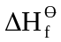 value for an element in its standard state must be zero.
(It takes no energy to form an element is its standard state from its constituent element in its standard state).
Experimental Measurements of Enthalpy
Experimental measurements of enthalpy change are generally based on knowing that the specific heat capacity of water is 4.2Jg⁻¹K⁻¹. The temperature change of a given mass of water is measured, and the energy change is found from:

Heat energy change = mass of water x 4.2 x temperature change (E = m × c × ΔT)

[Or to make sure the sign is always correct
Heat energy change = mass of water x 4.2 x (Starting temp – final temp) ]

This is converted to an enthalpy change by dividing the energy change by the number of moles (of the substance not in excess) and adding the appropriate sign; - for exothermic reactions and + for endothermic reactions.

Example
50cm³ of 1M HCl is placed in a polystyrene cup. 50cm³ of 1M NaOH solution is placed in a beaker. The temperature of each is 18ºC. The NaOH solution is then added to the HCl in the cup. The temperature increases to 24ºC.
Calculate the enthalpy change for this reaction.

Heat energy change = 100 x 4.2 x (18 – 24) = -2520 J

Moles HCl = Moles NaOH = 50 / 1000 x 1 = 0.05 mol

∆H^{θ} = -2520 / 0.05 = -50,400 J mol⁻¹ or – 50.4 kJ mol⁻¹ (3 sig fig)

The two main ways of investigating enthalpy changes are
- mixing substances in an insulated container, and
- using a calorimeter in a combustion experiment.

A typical experiment to determine an enthalpy change using an insulated container (to Measure the enthalpy of neutralisation of hydrochloric acid and sodium hyrdroxide) which takes steps to reduce errors is given below.

30 cm³ is a reasonable volume of liquid to use in an expanded polystyrene cup.
- Using a measuring cylinder, 30 cm³ of dilute hydrochloric acid is placed into an expanded polystyrene cup.
- A thermometer is placed in the solution and the temp is recorded every min for 3 mins.
- 30 cm³ sodium hydroxide solution is measured out.
- At 3.5 minutes the sodium hydroxide solution is added.
- The mixture is stirred continuously.
- Readings continue to be taken every minute up to ten minutes.

A graph of the readings is plotted and the lines extrapolated as shown in the diagram below.

Temperature
/ ºC
Temperature change for reaction
ΔӨ

3.5 mins

Time / mins

Likely errors in these experiments;
- Assuming the volume (and therefore mass) of water used in the calculation is the same as the volume of the solution used in the reaction.
- Assuming that the specific heat capacity of the solution is the same as that of water.

A calorimeter could be used to measure enthalpies of combustion.
A typical process for this is outlined below.
- A measuring cylinder is used to measure out 100cm³ of water.
- The water is placed in a calorimeter (basically a metal can).
- The liquid to be investigated is placed in a spirit burner. The spirit burner is weighed.
- The temperature of the water is noted
- The apparatus is set up as shown below.
- The liquid is ignited and allowed to heat the water.
- After a temperature rise of around 20ºC, the flame is extinguished.
- The exact temperature is noted
- The burner is weighed to find out how much liquid has been burned.
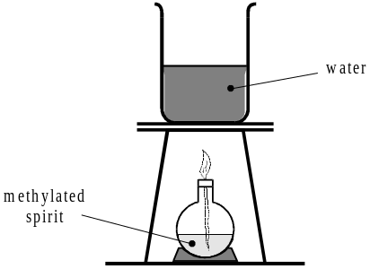
Typical results
Liquid | Mass of burner at start /g | Mass of burner at end /g | Temperature at start /ºC | Temperature at end /ºC
Ethanal, C₂H₄O | 115.78 | 115.59 | 21 | 29
Calculation
Energy = m x C x Ө = 100 x 4.2 x 8 = 3360 J
Moles = 0.19 / 44 = 0.0043
ΔH = -3360 / 0.0043 = -781,395 J/mol = -781 kJ/mol (3 sig fig).
Hess's Law and Energy Cycles

Hess's Law follows from the 1st law of thermodynamics (conservation of energy) and states that;

For a given chemical change, the overall energy change will always be the same whether the change takes place in one step or a number of steps. (It is independent of the route taken).

We can use Hess’s law to construct cycles, and then equate the enthalpies from different pathways. Remember that the direction of the arrow is directly linked to the sign of ∆H. If the arrow is reversed, then the sign of ∆H must be changed (see ∆H₄ in the example below).
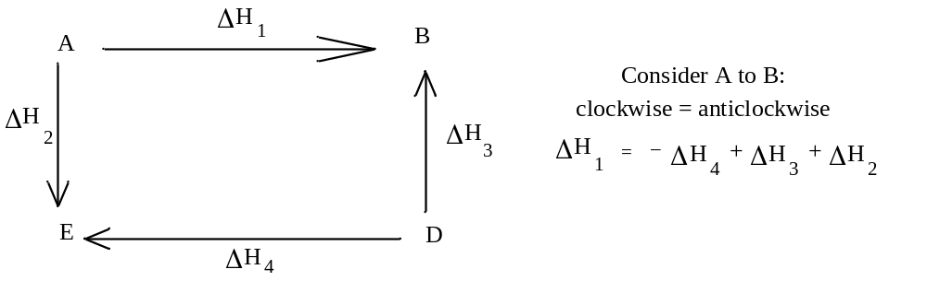
Example 1
The energy level of liquid water at 25ºC will be the same whether it is formed from burning hydrogen or the decomposition of hydrogen peroxide.
Suppose we wanted to find the enthalpy of formation of hydrogen peroxide, ∆H^{θ}_{f}(H₂O₂).
Chemical equation H_{2(g)} + O_{2(g)} → H₂O_{2(l)}

This reaction does not readily occur, and so we cannot measure its enthalpy directly.
Hess's Law can be used to find the value for it using other enthalpy values by constructing a cycle, and then equating the enthalpies from the different routes.

When 1 mole hydrogen is burnt in oxygen to form water, 285.9 kJ mol⁻¹ of energy are given out. This is the enthalpy of formation of water, ∆H^{θ}_{f}(H₂O).
H_{2(g)} + ½O_{2(g)} → H₂O_{(l)} ∆H^{θ}_{f} = -285.9 kJmol⁻¹
Hydrogen peroxide decomposes according to the equation:
H₂O_{2(l)} → H₂O_{(l)} + ½O_{2(g)} ∆H^{θ}_{R} = -98.3 kJmol⁻¹

These changes can be represented in an energy triangle. According to Hess’s law, the energy change to go from {H_{2(g)} + O_{2(g)}} → {H₂O_{2(l)}} is the same whether we go direct or via { H₂O_{(l)} + ½O_{2(g)}}.
H_{2(g)} + O_{2(g)} H₂O_{2(l)}
∆H^{θ}_{f}(H₂O₂)
H₂O_{(l)} + ½O_{2(g)}
∆H^{θ}_{f}(H₂O)
∆H^{θ}_{R}
The dashed arrow shows our indirect route {H_{2(g)} + O_{2(g)}} to {H₂O_{2(l)}}. When the dashed arrow points in the same direction as the energy change arrow, the value is added in. When the dashed arrow points in the opposite direction as the energy change arrow, the value is subtracted.

So using Hess’s Law;
∆H^{θ}_{f}(H₂O₂) = ∆H^{θ}_{f}(H₂O) - ∆H^{θ}_{R}
= -285.9 - -98.3 = -187.6 kJmol⁻¹
Example 2 – Calculating from enthalpies of combustion
The enthalpies of combustion of ethene, hydrogen and carbon are –1409, –286 and
–394 kJ mol^{–1}, respectively. Find the enthalpy of formation of ethene.

(i) Full cycle method
Construct a triangle with the elements in their standard states (including oxygen), ethene + oxygen, and the combustion products as the three corners.
2C(s) + 2H₂(g) + 3O₂(g)
C₂H₄(g) + 3O₂(g)

2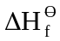(CO₂) + 2(H₂O)
= 2(–394) + 2(–286)
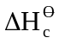(C₂H₄)
= –1409

2CO₂(g) + 2H₂O(l)

Using Hess’s Law, total enthalpy change from elements to ethene must be the same by either route.

= 2(CO₂) + 2(H₂O) – (C₂H₄)
= 2(–394) + 2(–286) – (–1409) = + 49 kJ mol^{–1}

N.B. Always include the + sign in ∆H answers for endothermic reactions.

Example 3 – Finding enthalpy of reaction from values

(ii) “Algebraic” method
* 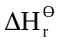 (reaction) must be added to all the enthalpies of formation on the left hand side of equation, to be equal to the total enthalpies of formation on the right hand side.
Write out this statement, then the equation, with plenty of space, and write the enthalpies of formation underneath each substance:

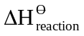 + sum of (reactants) = sum of (products)
C₂H₄(g) + 3O₂(g) = 2CO₂(g) + 2H₂O(l)
–1409 + (ethene) + 3( 0) = 2(–394) + 2(–286)

So (ethene) = 2(–394) + 2(–286) – (–1409) = + 49 kJ mol^{–1}

* The advantage of the algebraic method is that you are less likely to omit enthalpy values, and each value used is directly linked to the formula in the equation above, so that the layout is self-explanatory.

Using the algebraic method:

+ sum of (reactants) = sum of (products)
2 Al₂O₃ + 3C → 4Al(l) + 3CO₂
+ 2(–1669) + 0 = 4(+10) + 3(–394)
= –1142 – (–3338)
= + 2196 kJ mol^{–1} for 2 mol
so for 1 mol = + 1098 kJ mol^{–1}

Example 4 – use of enthalpies of combustion directly
Occasionally, instead of enthalpies of formation, only enthalpies of combustion (or solution) are given in a question (in Example 1, two of the enthalpies of combustion were also enthalpies of formation). These cannot be used in exactly the same way as enthalpies of formation, and you are less likely to make mistakes if you draw the full cycle out.

e.g. The enthalpies of combustion of ethyne(g) and benzene(l) are –1299 and
–3273 kJ mol^{–1}, and the enthalpy of vaporisation of benzene is +30kJ mol–1.
Find for: 3C₂H₂(g) → C₆H₆(g) (i.e. 3 ethyne → benzene)

Method: construct a cycle, including the combustion products. This means adding 7.5 oxygen molecules to both sides.
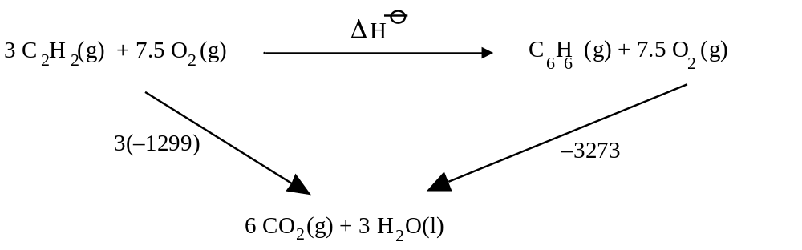
From Hess' Law: 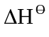= 3 (–1299) – (–3273) = –564 kJ mol^{–1}
Bond Enthalpy
When a chemical reaction takes place it involves bond breaking and bond forming.
When a bond is formed one electron from each atom enters a new electron cloud of lower energy. As the system moves to a lower energy level, energy is given out. In order to break the bond this energy has to be put back into the system.
The heat energy obtained when a bond is formed, and taken in when it is broken is called the bond enthalpy.
If we considered a molecule such as methane, the energy required to break each of the bonds is not exactly the same. So the total energy required to break up a methane molecule is divided by 4 to give an average bond enthalpy.
Average bond enthalpies can be used to determine approximately the enthalpy change which will take place in a particular reaction.

_{reaction} = sum of bonds broken on left – sum of bonds made on right

Consider the reaction between fluorine and methane.
CH₄ + 4F₂ → CF₄ + 4HF

For each mole
Bonds broken; C-H 4 x 412 = 1648 kJ Bonds formed; C-F 4 x -484 = -1936 kJ
F-F 4 x 158 = 632 kJ H-F 4 x -562 = -2248 kJ
Total energy used = +2280 kJ Total energy produced = -4184 kJ

Total enthalpy change for the reaction = Broken – Formed = +2280 -4184 = -1904 kJ.

We can show this on an energy diagram:
C + 4H + 8F

Enthalpy
–4184
+2280

CH₄ + 4F₂
ΔH = -1904 kJ mol^{–1}

CF₄ + 4HF

In reality the reaction between methane and fluorine does not required four fluorine molecules to collide with a methane molecule at the same instant, but actually takes place as a series of steps (in a process called the reaction mechanism).

Bond energies are useful as a guide to the possible sequence of events.
For example in the reaction between methane and fluorine, which is the first bond to break
C-H (bond enthalpy 412) or F-F (bond enthalpy 158)?
Since the F-F bond requires less energy to break it, this will be the first bond broken.

The bond enthalpies relate to the activation enthalpy for a reaction and therefore have an influence on how fast the reaction can go. If the bond enthalpies are low, then the activation enthalpy will be low and the reaction can take place at a high rate.
Reaction Mechanisms

A reaction mechanism shows which bonds are formed and broken during a reaction and informs chemists how a reaction proceeds.
The weaker the bond, the more likely it is to break.

Types of bond breaking
Bonds can break in two ways.

1) The electrons in the covalent bond return to their original atoms.
The species that form have an unpaired electron – they are called free radicals.
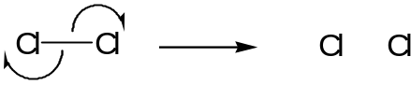

This is known as Homolytic fission (Homo as the products formed are both free radicals).

2) The electrons in the bond both move in the same direction.
The process forms ions and is called hetrolytic fission.
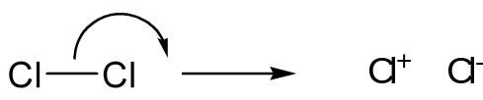

Probing reaction mechanisms
Bond enthalpies allow us to postulate what happens during a reaction.

e.g. The most likely bond to break in the molecule below (bromoethane) is the C-Br bond as it is the weakest.
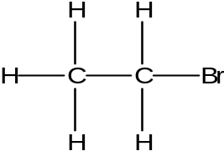

Bond | Bond enthalpy (kJ mol⁻¹)  (kJ/mol)
C-H | 413
C-C | 347
C-Br | 290

When bromoethane reacts the most likely mechanism for the reaction will involve the breaking of the C-Br bond to form the carbocationic intermediate (C₂H₅⁺) and a Br⁻ ion.
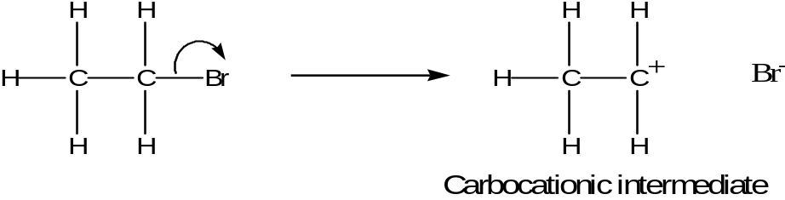
Bond enthalpies and enthalpies of Atomisation

The enthalpy of atomisation of an element is the enthalpy change when one mole of gaseous atoms of an element is formed from an element is its standard state under standard conditions (298K and 1 atm).
e.g. It is the enthalpy change for the following process:
1/2Cl₂(g) → Cl(g) ; enthalpy change = ΔH_{a}[1/2Cl₂(g)] = + 121 kJ mol⁻¹

During atomization all the bonds in the reactants are broken and no new bonds are formed (as all the products are atoms).
Therefore ΔH_{a} = The sum of all the bonds in the reactants.

For 1/2Cl₂(g) → Cl(g) the bonds broken = ½ (Cl-Cl)

Therefore Bond enthalpy of (Cl-Cl) = 2 x 121 = + 242 kJ mol⁻¹

Another example

ΔH_{a}[CH₄(g)] = +1646 kJ mol⁻¹

The equation for atomisation of CH₄ is; CH₄(g) → C(g) + 4H(g)

Bonds broken = 4 (C-H)

Therefore 4 (C-H) = 1646
(C-H) = 1646 / 4 = 412 kJ mol⁻¹

The bond enthalpy of (C-H) in CH₄ is 412 kJ mol⁻¹
Born-Haber cycles

Lattice enthalpies cannot be determined directly and are found instead by cycles, called the Born-Haber cycles, which are similar to the cycles used for determining enthalpy changes using Hess's law.

- Starting with the elements in their standard states, we first form gaseous atoms (atomisation enthalpies).
- We then remove electron(s) from the metal (ionisation enthalpy), and give electron(s) to the non-metal (electron affinity).
- The gaseous ions are now combined to form the crystal (lattice enthalpy).
- The alternative route is to form the crystal directly from the elements (enthalpy of formation).

We can illustrate the use of a Born-Haber cycle by calculating the enthalpy of formation of magnesium chloride (in order to compare with the observed value of –642 kJ mol⁻¹).
If there is good agreement, it is likely that the compound fits the ionic model well.

Mg²⁺(g) + 2e– + 2Cl(g)

2 × electron affinity of Cl
Mg: first I.E
+ second I.E.

Mg²⁺(g) + 2Cl–(g)

Mg(g) + 2Cl(g)

2 × atomisation
of Cl

lattice enthalpy
of MgCl₂(s)
Mg(g) + Cl₂(g)

atomisation
of Mg

Mg(s) + Cl₂(g)

enthalpy of
formation of MgCl₂

MgCl₂(s)

For the route via atoms, and gaseous ions, the values are as follows:

Process: Enthalpy Value for MgCl₂/kJ mol^{–1}
a) Elements to atoms Atomisation of Mg +150
2 × Atomisation of Cl +242
b) metal atom to cation First ionisation E of Mg +736
+ second I.E. +1450
c) non-metal to anion 2 × electron affinity Cl –728
d) ions to crystal lattice enthalpy of MgCl₂ –2493
Therefore: enthalpy of formation –643 kJ mol^{–1}

Note;
In (a) and (c) allowance is made for two Cl atoms, and in (b) the total energy needed is the sum of the first two ionisation energies.

In (d), the lattice enthalpy is defined as the enthalpy change on formation of one mole of crystals from the gaseous ions (see previous section), and is negative.

The Born-Haber cycle is a conventional Hess’s Law cycle, following the directions of the arrows, but the vertical heights give a rough idea of the enthalpy content (lower = thermodynamically more stable).

Study of this Born-Haber cycle shows that although the (negative) electron affinity of the non-metal goes some way towards compensating for the high ionisation energy, it is the large negative value for the lattice energy which makes the whole process favourable.

Ionic compounds are likely to be formed if one element (the metal) has low ionisation energy (or energies), the other (non-metal) has a reasonably high electron affinity, and if the lattice energy of the compound formed is high.

ATOMIC STRUCTURE AND PERIODICITY

Basic structure of the atom.
An atom contains protons, neutrons and electrons. The protons and neutrons are found in the nucleus of the atom while the electrons exist in the energy levels around the nucleus.
The characteristics of these basic particles are shown in the table

PARTICLE | RELATIVE MASS | RELATIVE CHARGE
Proton | 1 | +1
Electron | 1/1840 | -1
Neutron | 1 | None

The nucleus carries virtually all the mass of the atom and is positively charged.
Number of protons in the nucleus = the atomic number of that atom.
The total number of particles in the nucleus is given by the mass number.
Mass number = Protons + Neutrons
Number of neutrons in a nucleus = Mass number - Atomic number

The atomic and mass numbers can be shown with the symbol of the atom:

Mass number

X

Atomic number

In a neutral atom, there will be no overall charge, so the no. of electrons = no. of protons.

The chemical nature of the atom is determined by the number of electrons it has and in particular the electron arrangement.
So the atomic number tells us what type of atom we have.
The number of neutrons in a particular type of atom often varies.

One example of this is in hydrogen
1 proton
1 proton + 1 neutron
1 proton + 2 neutrons

Hydrogen-1 Hydrogen-2 Hydrogen-3
Deuterium Tritium

1

H

1

H

2

1

H

3

1

The atomic number for all these is 1 because they are all hydrogen atoms.
The mass number is different.

Atoms of the same type with different numbers of neutrons are called isotopes.

Carbon also has isotopes. C-12 is an important isotope in chemical definitions;
Relative Atomic Mass is the weighted mean of one mole of a normal sample of the element expressed on a scale on which one mole of the atoms of the C-12 isotope has a mass of exactly 12 units.

R.A.M. A_{r} = mean* mass of 1 atom of the element
one-twelfth of the mass of 1 atom of ¹²C

Relative Molecular Mass and Relative Isotopic Mass are measured on the same scale.
Relative Isotopic Mass is the mass of one mole of an isotope of the element expressed on a scale on which one mole of the atoms of the C-12 isotope has a mass of exactly 12 units.

R.I.M. = mass of 1 atom of the isotope
one-twelfth of the mass of 1 atom of ¹²C

Relative Molecular Mass is the weighted mean of one mole of a normal sample of the substance expressed on a scale on which one mole of the atoms of the C-12 isotope has a mass of exactly 12 units.

R.M.M. M_{r} = mean mass of 1 molecule of the substance
one-twelfth of the mass of 1 atom of ¹²C

The term relative molecular mass should only be applied to substances which have covalently-bonded molecules e.g. Cl₂, SO₂, C₈H₁₈. For ionic materials like NaCl and CuSO₄ the term relative formula mass is preferred, though it is calculated in the same way, by adding up the R.A.M.s of all the atoms in the formula. R.F.M. can be used for molecular substances, too.

The relative formula mass of a substance is:
R.F.M. M_{r =} the mean mass of one formula unit of the substance
one twelfth of the mass of one atom of ¹²C.

The Mass Spectrometer

The mass spectrometer is a method of determining relative atomic and molecular masses. The main processes involved are;
1. the sample is vaporised,
2. the sample is ionised,
3. the ions are accelerated by an electric field,
4. the accelerated ions pass through a magnetic field and are deflected,
5. the ions are detected and recorded.

Vaporised sample
Accelerating field

Electron gun

Magnetic field

Recorder

Tube under vacuum

Amplifier

Ion detector

The vaporised sample is fed into the ionisation chamber. Here it is bombarded by a stream of electrons which knock electrons out of the molecules in the sample.
X_{(g)} + e⁻ → X⁺_{(g)} + 2e⁻

These charged ions are then accelerated through an electric field and pass into a magnetic field. The magnetic field deflects the ions according to their mass and charge.

For a particular setting of electric and magnetic fields only particles of a certain mass reach the detector. Lower masses are deflected too much and higher masses too little.
The magnetic field strength is gradually altered changing the mass of particles which will reach the detector. The detector is connected to an amplifier and recorder so the mass of particles can be determined.

The mass spectrum of an element shows the relative isotopic mass and relative abundance of each isotope of the element being tested. In a mass spectrum the height of each peak = the relative abundance.
The Relative Atomic Mass of an element can be found by finding the sum of the products of the relative abundance of each isotope and its relative isotopic mass and the dividing by the total relative abundance.

e.g. The two sketches show the mass spectra obtained from atoms of two different elements. In each case determine the R.A.M.
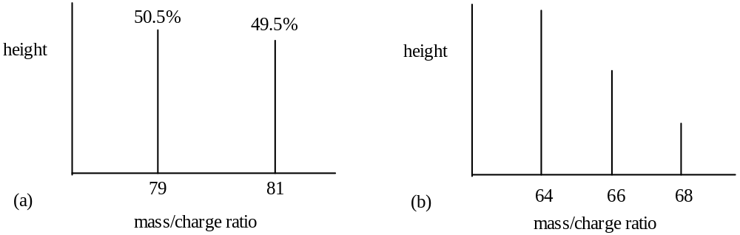
(a) We assume the two peaks are due to atoms of two isotopes.
Mean r.a.m. = 79 × + 81 × = 79.99 = 80.0 (to 3 s.f.)

(b) No scale is given, so we must use a ruler to measure the heights. Let us assume these are (from left to right) 3.8 cm, 2.4 cm, and 1.2 cm. Total = 7.4cm
Mean r.a.m. = 64 × + 66 × + 68 × = 65.3 (to 3 s.f.)

A very accurate version of the mass spectrometer can be used to determine relative isotopic masses to a high degree of accuracy: e.g. ¹⁶O = 15.99415 and ¹⁷O = 16.99913.

Mass Spectra of Molecules
The full mass spectrum of chlorine is more complicated than the examples shown on page 4. This is because chlorine is made up of diatomic molecules (molecules containing two atoms). Peaks occur at mass numbers 35, 37, 70, 72 and 74. The identity of these is as follows.
Peak at | Species responsible
35 | ³⁵Cl⁺
37 | ³⁷Cl⁺
70 | ³⁵Cl₂⁺
72 | ³⁵Cl³⁷Cl⁺
74 | ³⁷Cl₂⁺

Peaks still occur at mass numbers 35 and 37 because molecules break up in the mass spectrometer.

Example
Bromine has two isotopes of mass 79 and mass 81.
Predict the peaks you would expect to see in a mass spectrograph of bromine, Br₂.

Peak | 79 | 81 | 158 | 160 | 162
Species | ⁷⁹Br⁺ | ⁸¹Br⁺ | ⁷⁹Br₂⁺ | ⁷⁹Br⁸¹Br⁺ | ⁸¹Br₂⁺

When molecules are passed through the mass spectrometer, the peak with the highest mass is caused by the ion formed from the whole molecule – this is called the molecular ion or parent ion.

The RFM of a compound can be found from the mass value of the molecular ion.

Molecules of a particular compound will always break up in the same way and in
the same proportion when passed through a mass spectrometer. This means that a given compound will always produce the same pattern in a mass spectrum. This can be used to identify the presence of compounds in analysis.

This has been used as follows.
- In sport to detect the use of anabolic steroids
- By pharmaceutical industries to identify synthesized compounds as possible potential drugs

Independent research:
Research how the mass spectrometer used in space research.

Electronic Structure of the atom

The electronic structure of an atom that determines its chemical properties.
Electrons can be regarded as having certain energy levels. The lower levels fill before the higher levels are occupied.

The simple theory your learnt at IGCSE, pictures the atom as having shells, the shell of lowest energy being closest to the nucleus. The next shell can hold up to eight electrons. The third shell also holds up to eight electrons.

Bonding is explained in terms of atoms trying to obtain a stable electrons arrangement by;
(i) transfer from electron rich atoms(metals) to electron deficient atoms(non-metals);
(ii) sharing electrons between electron deficient atoms.

This model on its own is not sophisticated enough for understanding A level work fully and does not explain how the atoms arrange electrons above a number of twenty.

The simple bonding theory which comes from the model cannot explain the structure of molecules such as PCl₅ or SF₆.

Electronic Configuration
- The shells used in the simple view of the atom are divided into subshells.
Shell Subshells
1 s
2 s p
3 s p d
4 s p d f
- The higher the energy of the shell, the more subshells it contains.

Electrons inside the atom should be thought of as waves rather than particles.
The area occupied by an electron wave is called the orbital.
An orbital has no edge: the electron density just tails off more and more. However, we can calculate the surface which would contain a given percentage (say, 95%) of the electron density, and use this to gain an idea of the shape of the orbital (below).

It is important to remember that the electron density is not uniform within this shape.
The s-orbital is always spherically symmetrical, while the three 2p orbitals each point along one particular axis, at right angles to the other two. Remember that when one electron occupies a 2p orbital it occupies both halves; when two electrons occupy it, they both occupy both halves.

Each electron in an atom is different from all the other electrons.

The s subshell
s orbitals can contain a maximum of two electrons.
These have the same energy value, but are said to have opposite spin values.

The p subshell
There are three p orbitals, each of which can contain a maximum of two electrons.

The d subshell
There are five d orbitals, each of which can contain a maximum of two electrons.

Electron shells
- The first shell holds two electrons in an s subshell. 1s
- The electrons have the same energy value, but are said to have opposite spin values.

- The second shell holds eight electrons.
- These are split into two energy levels;
the lower level has two electrons in the 's' subshell 2s
the higher level has six electrons in the 'p' subshell. 2p
- The electrons in the 'p' subshell are found in three different regions of the atom which are called 'x', 'y' and 'z'.

Second shell
8 electrons

- The thrid shell holds eighteen electrons.
- These are split into three energy levels;
the lower level has two electrons in the 's' subshell 3s
the next highest level has six electrons in the 'p' subshell. 3p
the highest level has ten electrons in the 'd' subshell. 3d

Note - In the higher shells there is overlap between the energy levels of the subshells. E.g. The 4s subshell is filled before the 3d subshell.

Electronic configurations
Electronic Configuration can be predicted. If the following rules are followed:
- Electrons go into lower energy levels before higher ones.
- Electrons go into lower sub-shells before higher ones.
- Electrons occupy orbitals with 1 electron rather than 2 if possible.
- Electrons can only occupy the same orbital if they have opposite spins.
- The orbital order 1s, 2s, 2p, 3s, 3p, 4s, 3d, 4p

e.g.
Atom No of electrons Configuration
Si 14 1s², 2s², 2p⁶, 3s², 3p²
K 19 1s², 2s², 2p⁶, 3s², 3p⁶, 4s²
Mn 25 1s², 2s², 2p⁶, 3s², 3p⁶, 4s², 3d⁵
Ge 32 1s², 2s², 2p⁶, 3s², 3p⁶, 4s², 3d¹⁰, 4p²
Kr 36 1s², 2s², 2p⁶, 3s², 3p⁶, 4s², 3d¹⁰, 4p⁶

Another way of representing electronic configuration giving greater detail is as “electrons in boxes”
1s
2s
2p

N……. 7

When writing the electron configurations of ions, it is important to take into account the number of electrons lost or gained. Ca²⁺ 1s², 2s², 2p⁶, 3s², 3p⁶

An exactly half full or full d subshell is particularly stable. This gives chromium and copper what is at first sight an unexpected electronic configuration.
The extra stability of the exactly half full or full d subshell means that an electron from the 4s goes to the 3d to give a half full subshell for chromium and a full subshell for copper.

Element | Initially expected but wrong | Correct electron configuration
Chromium, Cr | 1s², 2s², 2p⁶, 3s², 3p⁶, 4s², 3d⁴ | 1s², 2s², 2p⁶, 3s², 3p⁶, 4s¹, 3d⁵
Copper, Cu | 1s², 2s², 2p⁶, 3s², 3p⁶, 4s², 3d⁹ | 1s², 2s², 2p⁶, 3s², 3p⁶, 4s¹, 3d¹⁰
Configurations and the Periodic Table

s, p and d-block elements
All s-block elements have their highest energy electrons in s-orbitals.
All p-block elements have their highest energy electrons in p-orbitals.
All d-block elements have their highest energy electrons in d-orbitals.

1s
2s
3s
4s
5s
6s
3d
4p
3p
2p
5p
6p
4d
5d

Evidence for Electron shells and subshells

Ionisation Energies
An electron is attracted to the positive charge in the nucleus of the atom. It is possible to remove an electron from an atom. The process of removing an electron form an atom to form a positive ion is called ionisation. The energy required to remove one electron from an atom is the first ionization energy.
The size of the ionisation energy is an indication of the strength of attraction between the outer electrons and the nucleus.

Energy changes in chemistry are generally measured as heat energy or enthalpy.
The definition of the first ionisation energy is:
The energy required to remove one electron from each atom in one mole of mole of gaseous atoms producing one mole of gaseous ions with one positive charge.

or
The enthalpy change for the following reaction:
X_{(g)} → X⁺_{(g)} + e⁻

Examples
The first ionization energy of chlorine Cl_{(g)} → Cl⁺_{(g)} + e⁻

The second ionization energy of sodium Na⁺_{(g)} → Na²⁺_{(g)} + e⁻

Successive ionisation energies
The graph of successive ionisation energies against number for potassium (At No 19) shows electrons grouped into four energy levels or quantum shells with similar energies.

Log
Ionisation Energy

Ionisation number

To remove the second electron it is necessary to break into a complete shell, so a lot more energy needed. Similarly with the tenth electron there is an increase in the energy required for its removal as this has to come from a complete shell.

From successive ionization energies it is possible to tell which group of the Periodic table an element is in. The table below shows successive ionisation energies for an element.
Energy values are given in kJmol⁻¹.

1st | 2nd | 3rd | 4th | 5th | 6th
577 | 1820 | 2740 | 11600 | 14800 | 18400

Notice that there is a large increase after the third ionisation energy – so the fourth electron is much more difficult to remove.
This means that there are three electrons in the outer shell, so the element is in group 3.

Example
Here are successive I.E. values in kJ mol-1 for two elements:
element X 1010 1900 2900 5000 6300 21300 25400 29800
element Y 590 1150 4940 6480 8120 10700 12300 14600 18200 20400 57100.
In what group of the periodic table are X and Y?

For X there is a sharp rise between the 5th and the 6th values, so X must have five electrons in it’s outer shell. X is a Group 5 element.
Y shows a jump between the second and third values, so it is in Group 2.
First ionisation energy
The first ionisation energy is energy required to remove one electron from an atom.

The factors which affect ionisation energies are:
- the nuclear charge,
- the distance away from the nucleus of the electron,
- the shielding of the nucleus by other electrons.
(Being spherical s subshells are much better at shielding than p subshells).

If first ionisation energy is plotted for a number of elements the results provide evidence for the existence of subshells.
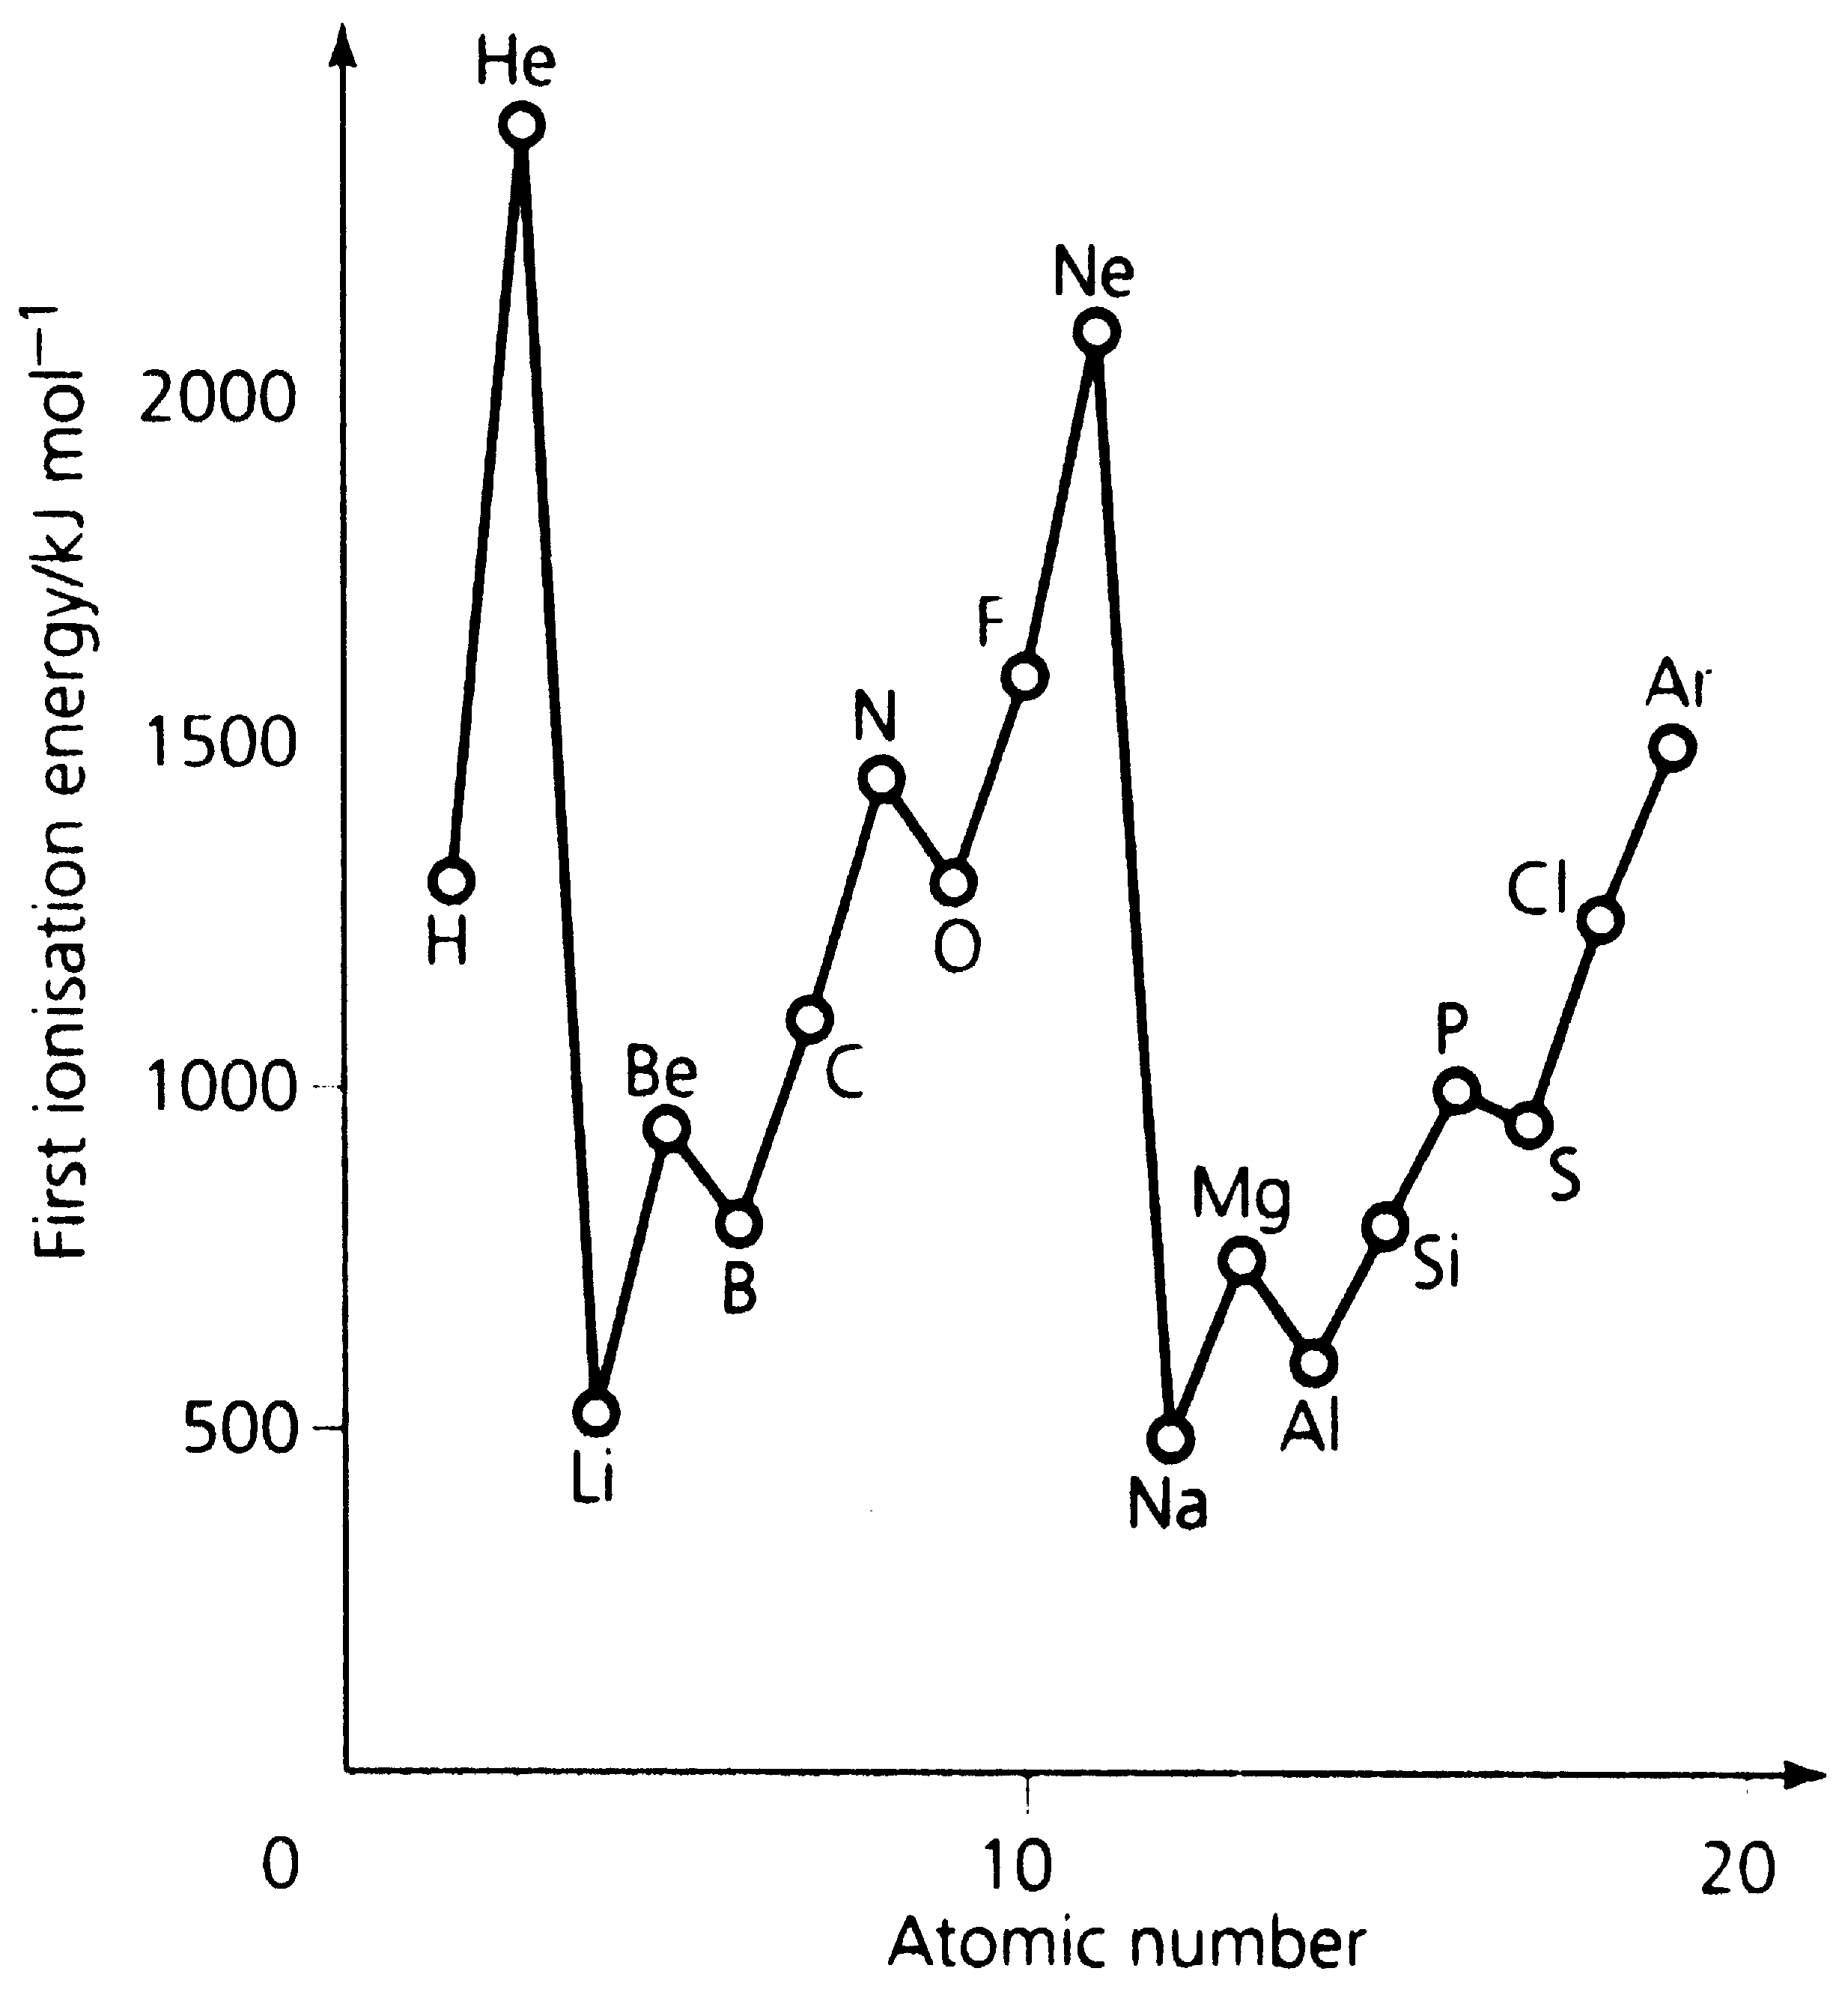

- Lithium has the lowest first ionisation energy of the second period.
- It is more difficult to remove an electron from Beryllium since the charge on the nucleus has increased Beryllium having a 4+ nuclear charge, whereas lithium is only 3+.
- Although Boron also has a higher nuclear charge, it has lower first ionisation energy because the electron is now in the 'p' subshell, and the inner ‘s’ subshell shields it from the nucleus.
- The ionisation energy increases again to Carbon and Nitrogen as the nuclear charge increases.
- Oxygen has a higher nuclear charge, but the first ionisation energy is lower because the extra electron now has to pair up in an orbital (in Nitrogen each p orbital has an electron in it) so the extra electron is repelled and it is easier to remove it.
- The values increase after oxygen as the nuclear charge increases.
- The pattern repeats itself for the next period of the periodic table – First ionization energy is a periodic property.

Periodicity
Periodicity is the regular occurrence of a trend across a period (or down a group).
Many periodic properties can be explained in terms of structure and bonding.
e.g. Explaining trends physical properties in period 3 from sodium to argon.

Na Mg Al Si P S Cl Ar

atom* radius / nm 0.157 0.140 0.126 0.117 0.110 0.104 0.099 –

ion radius / nm 0.098 0.065 0.054 no ion 0.212 0.184 0.181 –

ion charge +1 +2 +3 –3 –2 –1 –

structure metal metal metal diamond P₄† S₈ Cl₂ atomic

melting point / K 371 923 932 1683 317† 392 172 84

boiling point / K 1163 1390 2720 2630 553† 718 239 87

relative conductivity 1 1.23 1.96 semi 0 0 0 0

first I.E / kJ mol⁻¹ 500 740 580 790 1010 1000 1260 1520

†white P — red P, a polymer, sublimes at 863

(a) Atomic radii:
The radius of an atom depends on whether it is bonded to another one, and on the nature of the bonding (metallic, ionic, covalent). If we compare similar types of radius, the general trend is for atoms to get smaller across a period.
This is because the nuclear charge is increasing, and the extra electrons being added go into the same outer shell.
On the whole, electrons in the same shell do not shield one another very efficiently, and the size contracts as the effective nuclear charge increases.
The alkali metal, in Group 1, is the largest atom, and the halogen, in group 7, is the smallest.

(b) Ionic radii:
Ionic radii depend on the charge. Positive ions are always smaller than the neutral atoms, and higher charges make cations smaller still. Negative ions are much larger than neutral atoms, and larger still if the charge is higher.
From the table, it is clear that although Na atoms are larger than Cl, Na⁺ ions are much smaller than Cl⁻ ions.

(c) Melting points:
These depend on the type of bonding, and the structures of the solids.
Generally, going across a period metallic bonding at first increases in strength (Na<Mg<Al) as successive atoms have more valence electrons, and then gives way to a giant covalent structure (Si – like diamond), and then to molecular solids (P₄, S₈, Cl₂, Ar).
Melting points therefore tend to increase, reaching a maximum in the middle, and fall sharply to a minimum on the right (see table).
Values for the four molecules reflect the size of the molecule, and so the intermolecular forces (i.e. S₈ > P₄ > Cl₂ >Ar).
(d) Boiling points:
These are less dependent on crystal structure, and so give a better idea of the forces between the particles.
Again we can note the increase in metallic bonding from Na to Mg to Al; the high value for the giant molecule Si; the remainder are simple molecular structures.
For these, intermolecular forces again depend on size of molecule: P₄ < S₈; then there is a fall to Cl₂ and Ar, since they have weaker dispersion forces and lower boiling points.

(e) Electrical conductivity:
Along the series Na–Mg–Al the number of outer shell electrons which can be delocalised in metallic bonding increases, and the electrical conductivity increases accordingly.
By Si, however, the effective nuclear charge is too high to allow electron delocalisation, and Si is not a metal, although it is a semiconductor because an electron can be torn free relatively easily.
The remainder are non-metallic insulators: their effective nuclear charges are too great to allow electrons to escape under normal conditions.

(f) Ionisation energies:
The effective nuclear charge is the charge “seen” by an outer electron, after allowing for the effect of shielding. Thus for sodium (element 11), which has the configuration [Ne] 3s¹, ten of the nuclear charges are effectively shielded by the neon shells, and the effective nuclear charge on the outer electron is close to +1.
The first ionisation energies for the first 13 elements are shown below:
The general trend across a period in the Periodic Table, from Li to Ne, is for the values to increase sharply.
This is because, while the nuclear charge is increasing by one each time, the additional electron is being added in the same outer shell, and generally it is not shielded completely by the others.
However, there are two “kinks”. In Group 3 boron, 2s²2p¹, is lower than expected. This is because its 2p electron is sufficiently shielded by the 2s² pair for the effective nuclear charge to be lower than it was in Be.
In Group 6 oxygen, 2s²2p⁴, is also low. This is attributed to the fact that the fourth p electron has to be spin-paired, and so it is partly repelled by the other electron in the same orbital (also of note is that, once an electron is lost, O⁺ has a half-filled 2p sub-shell, and in general half-filled and completely filled sub-shells are particularly stable).
A similar pattern is followed in Period 3, with low values in Group 3 and Group 6. [Note that if second ionisation energies are plotted, the pattern is again similar, but this time shifted along one element e.g. Li⁺(1s²) is high, while Be⁺(1s²2s¹) is low.]

The general trend down a group is for ionisation energies to fall by a small amount. Although the nuclear charge increases, this is cancelled out by the addition of another closed shell, so the effective nuclear charge on the outer electron is similar, but the electron is further away from the nucleus, since it is being removed from a higher quantum number shell.

BONDING

In the process of bonding electrons move to a lower energy level to form a more stable structure. This can be done by transferring electron(s) to another atom or by pairing with an electron from another atom.

Covalent bonding
Two non- metal atoms can form a stable octet structure by sharing electrons.

Many simple covalent compounds obey the octet rule: the atoms form sufficient covalent bonds to make their outer shells up to eight electrons.

Example; chlorine

Cl
Cl

The shared electrons are positioned between the nuclei of each atom, and there is attraction between the positive nucleus of each atom and the shared electrons which holds the atoms together.

NUCLEUS
NUCLEUS
e

e

This is called covalent bonding. The two electrons which are shared are called the bonding pair.

Key Points on Covalent Bonding
- Electron deficient atoms share a pair of electrons to form stable electronic structures.
- The shared electron pair is attracted to the nuclei of each atom holding the atoms together strongly.
- Atoms joined in this way form molecules.
- Covalent materials may consist of simple molecules, polymers or giant molecules

Further examples
C
H
H
H
H

H
Cl

Hydrogen chloride

Methane

If two electron pairs are shared between the same atoms, they form a double bond,
as in CO₂, O₂:
O O
O C O

If three electron pairs are shared between the same atoms, they form a triple bond,
as in N₂:
N
N

Note that non-bonding electrons are paired up as “lone pairs”.

Physical Properties of covalently bonded compounds

Covalent compounds composed of simple molecules have weak intermolecular forces between the molecules. Little energy is needed to overcome these forces, so the melting and boiling points of these substances are low.

Giant molecular substances have strong covalent bonds throughout the structure and so require a large amount of energy to overcome them and these substances have high melting and boiling point.

In general covalent substances do not have free electrons, so they are non-conductors of electricity.
Graphite is exceptional as a covalent material in that it does have free electrons and so is a conductor.
(Details of diamond and graphite are covered in the “Shapes of Molecules and Ions” section).

Electron density maps
Electron density maps for covalent molecules can be plotted.
The electron density map for a molecule such as iodine is shown below.

The even distribution of electron density between the two atoms can be seen in this diagram.

Expansion of the octet
Although the octet is a particularly stable structure, it is possible for other stable structures to form. An atom can increase the number of single electrons it has, and so the number of bonds it can form by "splitting" an electron pair.

Sulphur is an example.
What would you expect the formula of sulphur fluoride to be? SF₂

Draw a dot and cross diagram of sulphur fluoride.

S
F
F

It is possible for an electron pair in sulphur to split. Splitting an electron pair takes in energy, but the extra energy produced by forming extra bonds makes it possible.
S
S

If an electron pair in sulphur is split, the sulphur can then form four bonds.

Example, SF₄
F
F
S

F
F

This process splitting electron pairs means that an atom in a compound can have more than 8 electrons, and it is referred to as expanding the octet.

Other examples are SF₆ and PCl₅.

S
F
F
F
F
F
F
P
Cl
Cl
Cl
Cl
Cl

Sulphur hexafluoride, SF₆
Phosphorus pentachloride, PCl₅

The elements in the second period do not do this because the energy to split the electron pair is too great to be compensated for by the formation of extra bonds, but elements below Period 2 form a number of compounds of this type.

Dative covalent bonding

Coordinate bonding or dative covalent bonding is similar to normal covalent bonding in that the bond consists of an electron pair. It is different in that instead of one electron coming from each atom, both the electrons come from a single atom.

Consider the structure of boron trifluoride and ammonia;
N
H
H
H
B
F
F
F

The boron only has three electron pairs in the outer shell. The nitrogen has a lone pair of electrons. These two molecules form a dative bond by the nitrogen using the lone pair to donate to the vacant site on the boron.
B
F
F
F
N
H
H
H

The following structure is formed
N
H
H
H
B
F
F
F

This can be represented as follows, with the dative bond represented by an arrow;
N
H
H
H
B
F
F
F

Other examples of the dative bond occur in the formation of the hydroxonium and ammonium ions;
H₂O + H⁺ → H₃O⁺

O
H
H
O
H
H
H
+
H
+
O
H
H
H
+

NH₃ + H⁺ → NH₄⁺

N
H
H
H
H
+
N
H
H
H
H
N
H
H
H
H
+
+

Metallic bonding

Metals can be visualised as being made up of positive ions surrounded by a cloud of electrons. Metals are electropositive; that is they tend to release their valence electrons and form positive ions. It is these electrons which make up the electron cloud.
The structure is held together by the attraction between these positive ions and the electron cloud or delocalised electrons.

+
+
+
+
+
+
+
+
+
+
+
+
+
+
+
+
+
+
+
+
+

This structure gives metals their properties. Since the bonding electrons are not fixed they are said to be delocalised, it means that a small potential difference will cause the electrons to move - making metals good electrical conductors.
Electron movement also assists in the conduction of heat energy- making metals good conductors of heat. The absence of fixed bonds allows the ions to move giving the characteristics of malleability and ductility.

Factors effecting the strength of metallic bonding:
1. The more valence electrons the stronger the bonding; as there is a higher
charge on the cations and there is a higher charge in the electron fields.

- The smaller the metal ion the stronger the bonding; as the electrons become
closer to the centre of the positive charge.

The metallic bonding determines physical properties of metals. The more valence electrons there are, the better the conductivity. The stronger the metallic bonding the higher the melting and boiling points.

Ionic bonding

Metal atoms hold their outer (valence) electrons weakly. Non-metals have a strong pull for the outer electrons. There is a tendency for metal atoms to transfer electrons to non-metal atoms.

NUCLEUS
NUCLEUS

When this happens the metal atom forms a positive ion (so metals are termed electropositive) and the non-metal atom forms a negative ion (non-metals are said to be electronegative). The ions formed have a stable "octet structure"

The strong electrostatic attraction between the cation and the anion lead to a strong ionic bond. This forms a giant structure built up of these oppositely charged ions.

The strong electrostatic forces within the giant structure mean that it requires a large amount of energy to break them down. As a result of this, ionic compounds have high melting and boiling points.

The ionic compounds are unable to conduct electricity in solid form, but when dissolved in water or in molten from the ions are free to move and so they conduct.

Sodium chloride is an ionic compound. The structure of this compound is shown here.

Key Points on Ionic Bonding

- An electron (or electrons) is transferred form one atom to another to form stable electronic structures.
- In this process positive and negative ions are formed
- The oppositely charged ions attract have very strong electrostatic forces
- A giant structure of ions is formed
- The compounds have high melting and boiling points
- The compounds do not conduct as solids, but do when molten or in solution.

Representing ionic compounds
Ionic substances are giant structures, but the essential electronic structure of an ionic compound can be represented by showing one set of ions.

Example - Sodium chloride

Simple electronic configuration Sodium: 2, 8, 1 Chlorine: 2, 8, 7

To form stable structures an electron is transferred from sodium to chlorine.

Sodium ion: 2, 8 Chloride ion: 2, 8, 8

A diagram to the ionic compound shows just the outer shell.
Na
+
Cl
-

Example 2 - Calcium bromide Calcium: 2, 8, 8, 2 Bromine: 2, 8, 18, 7

To form stable structures two electrons are transferred from calcium
one each to two bromine atoms.

Calcium ion: 2, 8, 8 Bromide ion: 2, 8, 18, 8

Ca
2+
Br
-
Br
-

Electron density maps
X rays can be deflected off solids to give us information about their structure. X ray diffraction of ionic solids can be presented as an electron density map. An electron density map shows lines which represent areas of equal electron density.
An idealised electron map for an ion pair in an ionic compound is shown to the right. It is important to remember that the lines do not represent shells.

In practice the situation is more complex as the cation can distort the electron field of the anion.

The electron density map for sodium chloride is shown to the left.
The distortion of the ions, particularly the chloride can be seen.

Sizes of ions in a Group
Going down a group of the Periodic Table, the ions formed have the same charge.
As the atoms from which they were formed become larger so do the ions.

Sizes of isoelectronic ions
Isoelectronic ions are ions that have the same number of electrons.

Atom | N | O | F | Na | Mg | Al
Number of electons | 7 | 8 | 9 | 11 | 12 | 13
Forms ions by | Gaining 3 electrons | Gaining 2 electrons | Gaining 1 electron | Losing 1 electron | Losing 2 electrons | Losing 3 electrons
Formula of ion | N³⁻ | O²⁻ | F⁻ | Na⁺ | Mg²⁺ | Al³⁺
Number of electrons | 10 | 10 | 10 | 10 | 10 | 10
Size of ion /nm | 0.171 | 0.140 | 0.136 | 0.095 | 0.065 | 0.050

As the ions all have to same number of electrons, the size of the ion is determined by the charge on the nucleus. As the nuclear charge increases from N to Al so does the attraction of the electrons to the nucleus and so the ionic size decreases.

Ionic compounds and Energy

Energy changes take place when ionic compounds are formed.
The process of bond breaking is endothermic and the process of bond breaking is exothermic. The energy changes that take place when an ionic compound forms are shown below.

Bond breaking
- Energy taking in - to convert the metal lattice into individual metal atoms.
- Energy taking in - to convert the non-metal molecules to individual non-metal atoms.

Ion formation
- Energy taking in - to convert the individual metal atoms into individual metal ions.
- Energy given out - when the individual non-metal atoms gain an electron to from an anion.

Bond forming
- Energy given out – as the cations and anions come together to form an ionic lattice - the Lattice Enthalpy.

This process is shown below for sodium chloride.
Sodium chloride
Sodium metal + chlorine molecules
Sodium atoms + chlorine atoms
Sodium ions + chlorine atoms
Energy to atomise sodium and chlorine
Energy to ionise sodium
Energy given as compound forms
Sodium ions + chloride ions
Energy given as chloride ions form
Energy given as the sodium chloride lattice forms

Such an energy diagram is called a Born-Haber cycle.
(It is not necessary to construct a Born-Haber cycle for Unit 1).

The Lattice Enthalpy can be calculated from this.

∆HL_{lat} = ∆H_{f} – (∆H_{at}{Na} + ∆H_{at}{Cl} + IE{Na}) – EA(Cl)

For sodium chloride
∆HL_{lat} = -411 – (109 + 121 + 494) – -364 = -771kJmol⁻¹

The values obtained from these Born-Haber cycles have to be found by experimental measurement of the various energy values and so are often referred to as experimentally determined lattice enthalpies.
They represent the actual lattice enthalpy, as opposed to a theoretical lattice enthalpy, which is based on a theoretical model for ionic compounds.

Considering Born-Haber cycles allows us to see why compounds have the formulae they do.

Take calcium chloride as an example.
Relevant values
1st ionization energy of calcium | 590kJmol⁻¹
2nd ionization energy of calcium | 1150 kJmol⁻¹
3rd ionization energy of calcium | 4940 kJmol⁻¹
Electron affinity of chlorine | -364 kJmol⁻¹
Lattice enthalpy of CaCl | -720 kJmol⁻¹
Lattice enthalpy of CaCl₂ | -2237 kJmol⁻¹
Atomization enthalpy of Ca | 193 kJmol⁻¹
Atomization enthalpy of Cl | 121 kJmol⁻¹

The enthalpy of formation can be found by rearranging the equation used above.
∆HL_{lat} = ∆H_{f} – (∆H_{at}{Ca} + ∆H_{at}{Cl} + IE{Ca}) – EA(Cl)
∆H_{f} = ∆HL_{lat} + (∆H_{at}{Ca} + ∆H_{at}{Cl} + IE{Ca}) + EA(Cl)

For CaCl ∆H_{f} = -720 + 193 + 121 + 590 -364 = -180 kJmol⁻¹

For CaCl₂ ∆H_{f} = -2237 + 193 + 121 + 590 + 1150 + 2x -364 = -790 kJmol⁻¹

More energy is needed to form Ca²⁺ but this is outweighed by the much larger lattice enthalpy, so the formation CaCl₂ of is energetically more favourable than for CaCl.

The lattice enthalpy of CaCl₃ is greater than for CaCl₂, but the extremely large amount of energy needed to form the Ca³⁺ makes the process energetically unfavourable.

Factors influencing lattice enthalpy.
The lattice enthalpy of an ionic compound is affected by the size and charge on the ions which make it up.
A decrease in the size of any ion increases the lattice enthalpy. This is because small ions can be close together and the smaller distance of separation the larger the attractive force between the ions.
An increase in charge also increases lattice enthalpy. This is because the force of attraction between ions increases as the charge on the ion increases.
Theoretical determination of lattice enthalpy
It is possible to calculate the lattice enthalpy by visualizing the ionic lattice as made up of perfectly spherical ions in a lattice. The lattice enthalpy is determined theoretically by calculating all the forces of attraction and repulsion in the lattice.

A simplified version of this is given below:
ΔH_{LE}º = – constant × 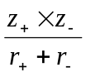 i.e. ∝ [product of charges] ÷ [sum of radii]
Here, the constant depends on the type of structure (the way in which the ions pack together). z₊ and z– are the charge on the cation and anion respectively, and r₊ and r– are the radii of cation and anion.

A comparison of the lattice energies of NaCl (–770 kJ mol^{–1}) and MgCl₂ (–2500 kJ mol^{–1}) shows a much more negative value for the magnesium compound: not only is z₊ double for Mg²⁺, but also its ion has a smaller radius (r₊), and this too leads to a larger lattice energy.

Comparing experimental and theoretical values for lattice enthalpy
The lattice energy is the energy change which occurs when well separated gaseous ions are brought together to form a crystal. As stated above, it is possible to obtain a theoretical value of the lattice energy by considering all the attractions and repulsions between the ions in the lattice.

The values obtained by using Born-Haber cycles are determined by experiment and reflect the actual value.

The table below compares theoretical lattice energies with experimental lattice energies.

Compound | Experimental value  / kJmol⁻¹ | Theoretical value  / kJmol⁻¹ | Difference in values / kJmol⁻¹
MgF₂ | -2957 | -2913 | 44
MgI₂ | -2327 | -1944 | 383

The compound magnesium fluoride has theoretical values which agree quite well with the experimental value, but the magnesium iodide values agree less well. In general the iodides tend to show a greater difference between these values than fluorides.

The experimental values show that lithium halides are actually more stable than would be expected by regarding them as purely ionic compounds. In the same way, iodides are in reality more stable than would be expected by treating them theoretically as purely ionic compounds. This discrepancy is caused by a covalent character which exists in the ionic lattice.
The greater the difference between the experimental value and the theoretical value, the greater the degree of covalency in the lattice.
This covalency is caused by polarisation.

Polarisation in Ionic Bonding
When an ionic bond is formed, the metal atom transfers one or more electrons to the non-metal and a cation (+) and an anion (-) are formed.

In perfect ionic bonding there is complete separation of charge. In polarised ionic bonding some of the electron charge on the anion is pulled back towards the cation.

Anion
-
Cation
+
Cation
+
Anion
-

The cation attracts electrons in the anion
The electron field around the anion is distorted

Polarisation occurs to different extents according to the ions involved

A highly ionic material

Polarisation

Considerable polarisation

The extent of the polarisation depends on how much the cation pulls on the electrons; the polarising power, and on how much the anion allows the electrons to be pulled away: the polarisability.

Polarising power is increased by higher positive charge and smaller cation.

Polarisability is increased by higher negative charge and larger anion.

Factors which increase polarisation in ionic compounds
1. increased charge on anion or cation,
2. increased size of anion,
3. decreased size of cation.

Low polarisation High polarisation
low charge (+1,-1) high charge (+3,-3)
small anion large anion
large cation small cation

e.g. K⁺F⁻ e.g. Al³⁺ (I⁻)₃

It is of course incorrect to regard ion pairs in isolation, because they actually exist in a lattice.

Polarisation of ionic compounds gives the compounds a covalent character.
The greater the polarisarion, the greater the covalent character.
The extent of this polarisation can be found by comparing theoretical and experimental lattice enthalpies.

When such a comparison was carried out with selected compounds in the previous section, it was seen that lithium and iodide compounds demonstrate significant covalent character.

Lithium has a high polarising power and iodides have a high polarisability.
The more polarised the compound, the greater the difference between the theoretical values and the experimental values.

Further example
compound | Lattice enthalpy value based on theoretical ionic model | Lattice enthalpy value based on experiment
sodium chloride | -766.1 kJmol⁻¹ | -776.4 kJmol⁻¹
silver chloride | -768.6 kJmol⁻¹ | -916.3 kJmol⁻¹

Sodium chloride is almost 100% ionic, hence the good agreement.
Silver chloride has a poor agreement and so has some covalent nature in its bonding.

INTRODUCTORY ORGANIC CHEMISTRY

Introduction
Organic chemistry is the study of carbon compounds excluding carbon monoxide, carbon dioxide and carbonates. Carbon atoms usually form four bonds. They have the unusual property of being able to join with other carbon atoms to form chains. This is known as catenation.

Organic chemicals occur in series such as alkanes, alkenes, alcohols and halogenoalkanes. These series are known as homologous series.

All the compounds in a particular homologous series have the same general formula and similar chemical properties.

Nomenclature
There are two components to the name of an organic compound.
The first part of the name is given based on the number of carbon atoms in the molecule.

First part of name
Number of C atoms | Name
1 | Meth-
2 | Eth-
3 | Prop-
4 | But-
5 | Pent-
6 | Hex-
7 | Hept-
8 | Oct-
9 | Non-
10 | Dec-

The second part of the name is given according to which homologous series they belong. Alkanes always have name endings of -ANE.
The part of the molecule that determines which group it is a member of, is called the functional group.

Second part of name

Functional group | Name of group | Name ending
C  C | Alkene | -ene
Cl  R | Chloro | Chloro-  Placed at front
Br  R | bromo | Bromo-  Placed at front
I  R | Iodo | Iodo-  Placed at front
H  O  R | Alcohol | -ol  See note below
C  H  O  R | Aldehyde | -al
C  R  O  R | Ketone | -one
C  O  R  H  O | Carboxylic acid | -oic acid

If a molecule contains an OH group, it will end with the name –ol.

If it contains another group, such as a carboxylic acid, the alcohol is named as hydroy- in front on the name, and the -oic acid at the end.

Rules for naming simple organic compounds

- Identify the longest “straight” carbon–chain (backbone).

- Number the carbon-chain from the end with the most functional groups attached. (Some functional groups, like –COOH, must be the first carbon atom, if possible).

- List the functional groups in alphabetical order, each prefixed by the number(s) of the carbon atom in the backbone to which it is attached. Dashes separate numbers and words.
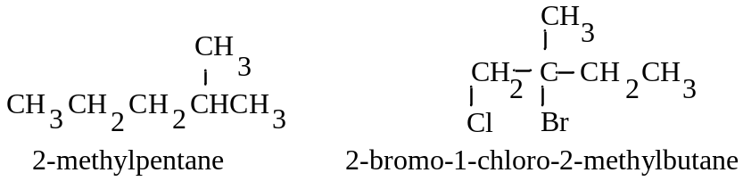

- Some groups appear at the end of a name. Numbering here starts from the end of the chain which is nearest to one of these groups:
e.g. CH₃CHBrCH(OH)CH₃ is 3-bromobutan-2-ol

Examples
propan-2-ol CH₃CH(OH)CH₃
the dash - separates numbers and words.

2,5-dimethylheptane C₂H₅ CH₃
| |
CH₃CHCH₂CH₂CH₂CH₃

1-bromo-2-chloroethane CH₂Cl-CH₂Br

But-1-ene CH₃ - CH₂ - CH= CH₂

1,2-Dibromopropane CH₃CH(Br)CH₂Br
numbers are separated by commas

Types of formulae

The empirical formula of a substance shows the simplest ratio of atoms in the compound (e.g. for alkenes, CH₂), while the molecular formula shows the actual numbers of atoms of each element in one molecule (e.g. C₄H₈ for butene).

The semi-structural formula of a compound shows the order in which the atoms are bonded together in one molecule of the compound: from it one must be able to work out all the atoms to which each particular atom is bonded (e.g. CH₃CH₂CH=CH₂ for but-1-ene; CH₃CH=CHCH₃ for but-2-ene).

The structural formula shows both the relative placing of the atoms, and the number of bonds between them:
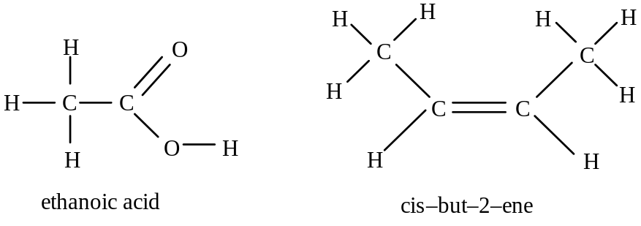

The skeletal formula is a simplified version showing bonds between C atoms and any functional groups, but omitting other C and H atoms. Each end of each line in the main skeleton shows a C atom, but a bond to a functional group does not end in a C (e.g. C—Br becomes —Br, and C—OH becomes —OH, while C—CH₃ becomes — ). Examples:
Br

OH

butan-2-ol 4-bromo-2-methylpent-2-ene

A general formula is used to represent members of a homologous series.
e.g. alkanes C_{n}H_{2n+2} or CH₃(CH₂)_{x}CH₃
primary alcohols C_{n}H_{2n+1}OH or CH₃(CH₂)_{x}OH.
Each member of a homologous series differs from the next by one CH₂ group:

Using of Organic Chemicals

Many organic chemicals and reagents used in their reactions have properties that mean they need to be handled with care.
The dangers presented by these chemicals such as flammability, being irritant or being carcinogenic, are called hazards.
When these materials are handled, the likelihood of the hazards they present being realized is called the risk.
In a practical using hazardous chemicals, the likely dangers and how they can be minimized is carried out in a risk assessment.

Ways in which risk can be minimized include;
- Working on a smaller scale
- Taking specific precautions or using alternative techniques
- Use an alternative procedure that involves less hazardous substances

Alkanes and Alkenes

The Alkanes

Alkanes are hydrocarbons (i.e. compounds of carbon and hydrogen only).
They are called saturated hydrocarbons because they contain no double bonds, and so cannot undergo addition reactions.

They have the general formula : C_{n}H_{2n+2}

Physical Properties
The boiling points of the alkanes increase steadily with the number of C atoms.
This is because the van der Waals’ forces between the molecules increase with the total number of electrons in the molecule. As the chain length increases, the van der Waals’ attractions increase, and the liquid needs to reach a higher temperature before the molecules can acquire enough energy to separate and go into the vapour state.
As isomers become more highly branched, boiling points usually fall slightly.
This is because the branching means that the molecule has less surface area in contact with its neighbours, thus decreasing the van der Waals attractions.

Isomerism

Isomerism is when two molecules of the same molecular formula have a different arrangement of atoms (structural formula).

There are two main types of isomerism: structural isomerism and stereoisomerism.

Structural isomers: these have different structural formulae. i.e. the atoms are joined together in a different order.
At the most extreme, they may have different functional groups: e.g. C₂H₆O may be ethanol, CH₃CH₂OH, or it may be methoxymethane (an ether), CH₃OCH₃.
Alternatively, they may have similar functional groups, but differ in the position of these in the molecule: e.g. propan-1-ol, CH₃CH₂CH₂OH, and propan-2-ol, CH₃CH(OH)CH₃.
Or they may differ only in the hydrocarbon chain (see below):

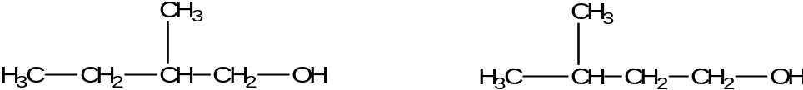
2–methylbutan–1–ol 3–methylbutan–1–ol

Stereoisomers.
These have the same structural formulae, and differ only by the arrangement of the atoms in space. There are two sorts: cis-trans (or geometrical), and optical. Optical isomerism will be looked at next year.

Isomers of alkanes
Alkanes exhibit structural isomerism.

e.g. Isomers of pentane
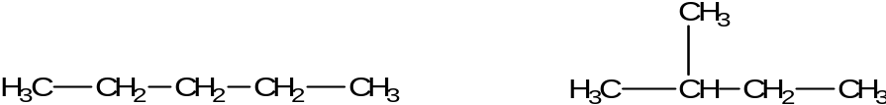
Pentane methylbutane
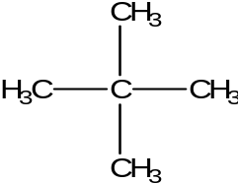
Dimethylpropane

e.g. Isomers of hexane
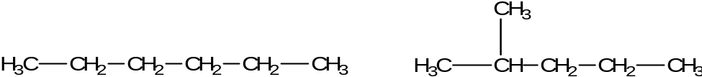
Hexane 2-methylpentane

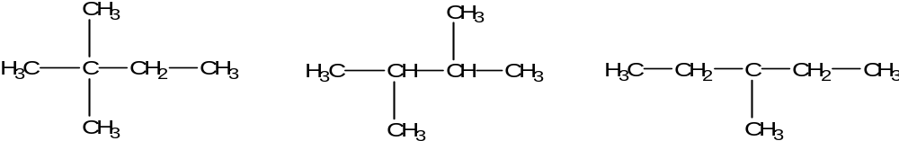
2,2-dimethylpropane 2,3-dimethylpropane 3-methylpentane

Fuels

One of the main uses of alkanes is as fuels.
Crude oil consists of a mixture of a large number of hydrocarbon compounds.
Crude oil undergoes fractional distillation, and the fractions obtained by this process consist of mixtures of hydrocarbons that boil within particular ranges.
The more useful fractions are those with the lower boiling ranges, such as that of gasoline which is used for petrol, but they generally occur in smaller proportions.

To convert some of the larger, less useful alkanes into smaller, more useful alkanes the process of cracking is used.
Cracking involves passing the alkane vapour through a heated catalyst.
The alkane molecules break up to form a smaller alkane molecule and at the same time an alkene, such as ethene, is formed which can then be used to make polymers.
A typical cracking reaction might be:
C₁₀H₂₂ → C₈H₁₈ + C₂H₄

The straight chain alkanes do not burn very evenly, and tend to cause “knocking” in a car engine. Branched alkanes burn more smoothly and are much more appropriate for modern high-performance engines.
The petrochemical industry carries out the process of reforming to convert straight chain alkanes into branched chain alkanes.

Hydrocarbon fuels produce carbon dioxide when they burn.
Carbon dioxide is a “greenhouse gas”. When infra red radiation from the sun hits the Earth’s surface, it is absorbed and then re-radiated at a lower frequency.
A greenhouse gas absorbs the re-radiated infra red and converts it to heat energy, so causing a warming of the atmosphere. This means that the production of carbon dioxide by burning fossil fuels increases the concentration of greenhouse gases in the atmosphere and is considered to cause climate change.
The problem of climate change means that there is a search for alternative fuels which do not place greenhouse gases in the air.

Chemical properties of alkanes

Alkanes contain carbon-hydrogen bonds, and, from ethane on, carbon-carbon single bonds. These are all non-polar, and the electron density in the σ-bonds is hard to distort (not polarisable), so that alkanes do not react with electrophiles or nucleophiles, or other polar reagents, like acids, alkalis or aqueous oxidising agents.

The bonds can only undergo homolytic bond fission, which occurs when a covalent bond breaks in such a way that each atom takes one electron. This leads to formation of two free radicals.

A free radical is an atom, or group of atoms, which have an unpaired electron. It is normally highly reactive, and written with a dot (which does not show an extra electron, simply the unpaired one). e.g. Cl• or CH₃•.

Alkanes therefore undergo very few reactions: combustion and cracking are the most important.

Reactions of alkanes

(a) Combustion
Alkanes burn in a plentiful supply of air or oxygen, to give carbon dioxide and steam:
CH₄ + 2O₂ → CO₂ + 2H₂O

If air is restricted, carbon monoxide is likely to be formed:
CH₄ + 1½ O₂ → CO + 2H₂O

The former reaction gives out much heat, and so alkanes are useful fuels. Methane itself is called natural gas, and is used in the home and in modern gas-turbine power stations.

(b) Halogenation
It is possible for the hydrogen atoms in the alkane to be substituted by chlorine or bromine.
Alkanes react with chlorine or bromine, in the presence of light, or on heating, to form halogenoalkanes and the hydrogen halide:

For example the reaction between methane and chlorine can be represented as follows:
H
H
H
C
Cl
H
H
H
H
C
Cl
Cl
H
Cl
+
+

The reaction does not necessarily stop at one substitution, and the reaction between methane and chlorine produces dichloro-, trichloro- and tetrachloro- methane.

CH₄ + Cl₂ → CH₃Cl + HCl

CH₃Cl + Cl₂ → CH₂Cl₂ + HCl

CH₂Cl₂ + Cl₂ → CHCl₃ + HCl

CHCl₃ + Cl₂ → CCl₄ + HCl

The process of substitution is random, so all possible products result, though if there is excess methane the main one will be CH₃Cl, while a large excess of chlorine will give mainly CCl₄.

The substitution of a hydrogen atom by a chlorine atom actually takes place in a number of stages. Looking in detail at what happens in each stage of such a reaction is called the reaction mechanism.
The halogenation of an alkane takes place by a free radical reaction.

The reaction between alkanes and these halogens requires an energy source such as ultra violet (u.v.) light. Considering the reaction between methane and chlorine, looking at the bond enthalpies for the bonds present

Bond | Energy kJ/mol
C-H | 413
Cl-Cl | 242

It can be seen that the Cl-Cl bond requires less energy to break, so this is the bond which is broken by the u.v. light.
Cl
Cl
Cl
Cl

This energy is used to split the halogen molecule to form two chlorine atoms; the chlorine atoms have an unpaired electron – such a species is called free radical.

The chlorine radical reacts with a methane molecule. It forms a bond.
Looking at the bond enthalpies for the bonds that could be formed;

Bond | Energy kJ/mol
C-Cl | 339
H-Cl | 431

It can be seen that the H-Cl bond has a higher bond enthalpy, so this is the bond which forms.
C
H
H
H
C
H
H
H
H

Cl
Cl
H
+
+

This forms a methyl radical. The methyl radical then reacts with a chlorine molecule:
C
H
H
H

Cl
Cl
+

C
H
H
H
Cl

Cl
+

In this reaction a chlorine radical is generated; this then reacts with a methane molecule and the process continues.

Curly arrow mechanisms

Reaction mechanisms look at the movement of electrons within and between molecules and ions. The movement of electrons are shown by “curly arrows”, using for a single electron and for an electron pair.

The first step in the reaction between methane and chlorine is the formation of the chlorine radical. This is called the initiation step. It is shown as follows.

Cl
Cl
Cl
Cl

The chlorine radical then attacks the methane molecule.
CH₄ + Cl• → CH₃• + HCl

The methyl radical from this reaction reacts with a chlorine molecule to form chloromethane and a new chlorine radical.
CH₃• + Cl₂ → CH₃Cl + Cl•

The chlorine radical starts the cycle again and the process continues.
These two reactions are called the propagation stage.

The propagation stage continues until two radical meet to form a molecule.
There are three possibilities for this reaction. Since the ends the sequence it is called the termination stage.
Cl• + Cl• → Cl₂
Cl• + CH₃• → CH₃Cl
CH₃• + CH₃• → C₂H₆

The overall mechanism is called free radical substitution.

Note that in the propagation stage the Cl• at the end can go on to attack another CH₄ and so the chain can go on for several thousand reactions from one initiation.

The presence of traces of C₂H₆ in the products shows that CH₃• radicals must have been formed.

Of course, the Cl• atoms can remove a hydrogen atom from CH₃Cl, and so the reaction can go on to CH₂Cl₂, then CHCl₃ and finally CCl₄.
The Alkenes

Alkenes are hydrocarbons that contain one double bond.

They are unsaturated compounds: compounds which are able to undergo addition reactions.

They have the general formula : C_{n}H_{2n}

The double bond in alkenes does not consist of two identical bonds.
One of the bonds is a normal bond with the electron cloud lying between to two atoms. This is called a sigma, σ, bond.
The other bond has an electron cloud which is placed above and below the two atoms. This is called the pi, π, bond.

The electron clouds in ethene can be represented as shown below.

Isomers of alkenes (E-Z Isomerism)

The geometry of the C=C bond is determined by the π-bond, and means that ethene is a rectangular, flat molecule.
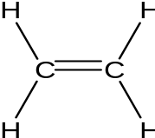

The bond angles are at about 120º, and rotation about the C=C axis is restricted, since twisting through 90º would mean the p-orbitals would no longer overlap and the π-bond would be broken.

The restriction of rotation produces isomers called E-Z isomers (geometric isomers or cis-trans isomers).
For E-Z isomerism (cis-trans isomerism) to occur there must be a double bond and two different groups on each of the double bonded carbon atoms.

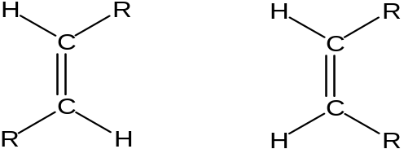
E- isomer (trans)
Z- isomer (cis)

E-Z and cis-trans are different terms for the same type of isomerism.

Trans refers to the isomer where the R groups are on opposite sides of the C=C.
Cis refers to the isomer where the R groups are on the same side of the C=C.

Isomers of butane
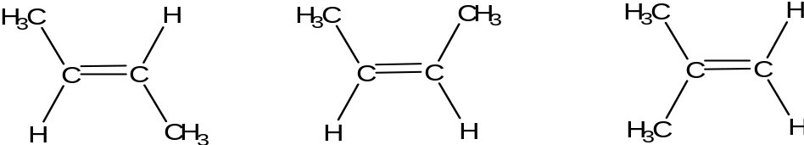
2E but-2-ene 2Z but-2-ene 2–methylpropene
trans but-2-ene cis but-2-ene

The E-Z (cis / trans) isomers will be chemically very similar, though not quite identical, and will have slightly different melting and boiling points.
[Note that a third isomer, 2–methylpropene, which has two methyl groups attached to the same carbon atom, is a structural isomer of these, as is but-1-ene]

E- and Z- vs cis-trans nomenclature
The cis trans system breaks down with examples like;

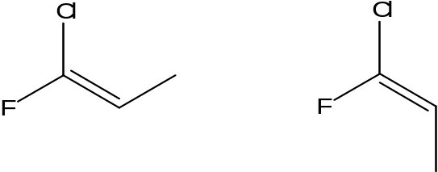

The E-Z naming system is more useful than the cis-trans system.
- The naming of the isomer is determined by priorities.
- Each atom on the double bond is given a priority determined by its atomic number.
- The smaller the atomic number the lower the priority – hydrogen in the example above.
- If atoms with the lowest priority are on the same side on each end of the C=C the isomer is called the Z-isomer. (Z=Zusammen (together)).
- If atoms with the lowest priority are on the same side on each end of the C=C the isomer is called the E-isomer. (E=Entgegen (opposite)).
Reactions of alkenes
The alkenes are more reactive than the alkanes because of the C=C bond.
It is possible for the double bond to break, allowing each carbon to form a new bond, which is often energetically favourable. Halogens, hydrogen halides, hydrogen and potassium manganate(VII) will produce addition reactions with alkenes.

Addition of hydrogen (hydrogenation)
Alkenes react with hydrogen in the presence of a nickel catalyst at150ºC.
R
H
H
C
C
R
H
H
H
H
H
R
H
C
C
R
+

This is important in the hydrogenation of vegetable fats to make margarine.
An unsaturated vegetable oil is mixed with a nickel catalyst at 50ºC,and hydrogen gas bubbled through. The saturated product has a higher melting point, and is less easily oxidised (longer shelf life).

Addition of bromine
Alkenes will decolorise bromine immediately:
H
R
H
C
C
R
+
Br
Br
R
H
H
C
C
R
Br
Br

The decolorisation of bromine water is used as a test for the C=C double bond.
This reaction occurs in an inert solvent like volasil.

Addition of chlorine
+
Cl
Cl
H
R
H
C
C
R
R
H
H
C
C
R
Cl
Cl

Addition of Hydrogen chloride*
+
H
R
H
C
C
R
Cl
H
R
H
H
C
C
R
Cl
H

Addition of Hydrogen bromide*
+
H
R
H
C
C
R
Br
H
R
H
H
C
C
R
Br
H

* When addition of a hydrogen halide takes place, if the alkene is not symmetrical, the hydrogen adds to the carbon that already has the most hydrogen. This is called Markovnikoff's rule
H
H
C
C
C
H
H
H
H
Br
H
+
H
C
C
H
H
H
H
C
H
H
Br

Reaction with Potassium manganate(VII)

Acidified potassium managanate(VII) is decolourised (from purple to colourless) by an alkene and a diol is formed.

H
R
H
C
C
R
+
[O]
H₂O
+
R
H
H
C
C
R
OH
OH

[O] is a shorthand for the oxidizing agent potassium manganate(VII).
Addition Reactions of Alkenes

The addition reactions have a mechanism which we need to study.
It is the electron rich area in the double bond which causes the initial attack.
A molecule attacking such an area is called an electrophile (electron loving). This reaction results in addition, so this type of reaction is called electrophilic addition.

A definition of the term electrophile is;
An electrophile is a species attracted to an area of negative charge and is an electron pair acceptor.

Mechanism for the reaction of hydrogen bromide with ethane.
Looking at dot and cross diagram for the reaction.
H
H
H
H
C
C
This is not the way a mechanism is shown.
1. The hydrogen in the hydrogen bromide has a partial positive charge. It is attracted to the high electron density in the double bond.

H
Br

H
H
H
H
C
C
H
Br
2. The hydrogen draws an electron pair out of the double bond and forms a bond to the hydrogen.

3. The bond between the bromine and the hydrogen weakens and breaks, both the electrons going to the bromine.

H
H
4. The carbon on the right now has only three of its original four electrons, so it has a positive charge. This intermediate is called a carbocation ion.
+
C
C
H

H
H

-
5. The bromine has gained an electron making it a bromide ion with a negative charge.
Br

H
H
H
H
C
C
H
Br
6. The bromide donates an electron pair to the positively charged carbon forming a bond.

The reaction mechanism for this is shown as follows.
H
H
H
H
C
C
H
-
H
H
H
C
C
H
H
H
H
H
C
C
Br
+
H
Br
H

Br

The mechanism for the attack of bromine on ethane is almost identical, but as bromine is not a polar molecule it has no partial charge.
As a bromine molecule approaches the ethane, the high electron density in the double bond repels electrons in the nearest bromine so causing an induced partial positive charge.
H
H
H
H
C
C
Br
H
H
H
H
C
C
Br
+
-
H
H
H
H
C
C
Br
Br
Br
Br

Asymmetric Additions (Markovnikoff's rule)

The addition of hydrogen bromide to propene could lead to two possible intermediates.

H
H
H
C
C
H
Br
H
H
H
H
H
C
C
H
H
C
H
H
H
H
C
C
H
H
C
+
H
H
C
H

+
H

If the hydrogen joins the central carbon the ion on the left will be formed.
If the hydrogen joins the end carbon the ion on the right will be formed.

H
H
H
H
C
C
H
Br
H
H
C
H
H
H
H
C
C
H
H
C
H
+
Br
-
The carbocation ion with the charge on the central carbon is formed as the charge is stabilised by the two carbons on each side of it. So the mechanism is as follows

H
H
H
H
C
C
H
H
C
H
Br

Markovnikoff's rule states that;
When addition of a hydrogen halide takes place, if the alkene is not symmetrical, the hydrogen adds to the carbon that already has the most hydrogen.

Test for alkenes
The addition reactions are used to test for the presence of a double bond.
If bromine water is added to an unsaturated compound, an addition reaction occurs fairly rapidly and the bromine water changes from orange to colourless.
In this test the product contains a Br and an OH.
This is because the bromine water contains hydroxide ions from water.
The reaction mechanism for the test on ethene shows why this product is formed.
H
H
H
H
H
H
+
C
C
C
C
C
C
OH
Br
Br

H
H
H
H
H
H
-
OH
Br

Br
OH- from the water takes place in the second step.

Addition Polymers
An addition polymer is formed when monomers containing double bonds are polymerised.
In the process of polymerisation the double bond breaks and the molecules join to form molecules of thousands or millions of units.

Polymer structure of structure of
Monomer polymer
C
C
H
H
H
H
C
C
H
H
H
H
n
Ethene

C
C
H
CH₃
H
H
n
H
CH₃
C
C
Propene
H
H
C
C
H
Cl
H
H
C
C
H
Cl
H
H
C
C
H
Cl
H
H
n

Chloroethene

C
C
F
F
F
F
C
C
F
F
F
F
n

Tetrafluoroethene

Independent research: Consider the uses of energy and resources over the life cycle of a polymer in the context of how renewable resources, recycling and energy recovery can lead to a more sustainable use of materials.

